YESTEM Insight (Accessible version)
Original version: https://yestem.org/wp-content/uploads/2022/09/2022-YESTEM-Insight-Equity-Compass-Funders-Edition.pdf

The Equity Compass: A tool for supporting socially just practice – Funders Edition

What is the Issue?
- In the UK and internationally, there are persistent inequalities across many aspects of society, from education and employment to healthcare and wellbeing.
- Funders play a key role in determining the range, scope and focus of research and development activities, as well as building capacity and providing thought-leadership and strategic direction within their sectors.
- Equality, diversity and inclusion are key priorities for many funders. By embedding equity within policy and practice and creating inclusive research and development cultures, funders can help tackle injustices and make a positive difference to society and people’s lives.
- In this insight, we introduce the Equity Compass and explain how this research-based, co-designed reflective framework can be used by funders. This tool can inform different aspects of funders’ work, including strategy, funding calls, grant assessment and auditing.
Whereas equality means treating everyone the same and providing everyone the same opportunities, an equity approach advocates for differential treatment of people according to need, while also recognising and valuing differences between people. A social justice approach seeks to change the structures and practices that create and maintain inequalities.

The Equity Compass: A tool for supporting socially just practice
- The Equity Compass is a tool that can help funders to reflect on and develop their policy and practice, adopting a social justice mind set.
- Adopting an equitable approach to funding is not just about what you do, but how and why you do it. This applies to both strategy and investments. The stance taken and the principles underlying your work can profoundly shape its potential for either reinforcing, or transforming, social inequalities. The Equity Compass can support funders to consider multiple dimensions of equity, as represented by the four overarching areas and the eight sub-dimensions of the Compass.
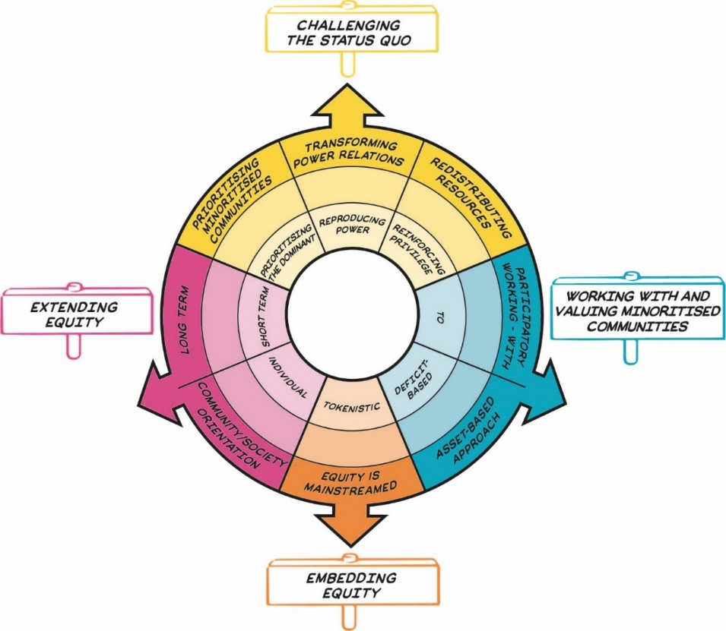
Figure 2: The Equity Compass showing eight dimensions of equity, grouped into four overarching areas represented by signs that sit outside the main circle. Details are presented in Table 1.
The Equity Compass was originally co-developed and iterated in partnership with informal science, technology, engineering and mathematics (STEM) learning settings, such as science centres, zoos and afterschool clubs. It has since been adapted and applied more widely, by teachers, senior leaders and funders in and beyond STEM.

The Equity Compass: How to use it
- By attending to the different areas and dimensions, the Equity Compass can help funders to better support all stakeholders and beneficiaries, but particularly those from less powerful and minoritised communities.
- The Equity Compass can help you recognize and think about key dimensions of equity/social justice – and consider how equitable your strategy and investments are. Each axis of the Equity Compass has a set of associated Guiding Questions to help you to reflect on your policy and practice from an equity perspective. For example, where would your current approach sit on each axis? Being positioned closer to the outer edges indicates stronger equitable practice.
- The Equity Compass can be used to identify areas that you might like to develop further. For example, you might want to prioritise an area where your mapping sits closer to the centre of the Equity Compass. The Guiding Questions can help prompt the ideas about how future activities could be planned in line with the eight dimensions of equity.
- Start small. You might be facing constraints that make it difficult to address all the equity dimensions at once. Identify the areas that you can act on now, while keeping in mind the plans for longer term development. Small changes can make a difference – equitable practice is an ongoing journey.
- You could also use the Equity Compass to evidence your progress towards more equitable practice by charting outwards movement on the axes. You could draw or map your current practice on to the Equity Compass and then repeat the exercise at a later point to map change. You might find it helpful to use the worksheet provided at the end of this insight to record your reflections and plans.

The Equity Compass: A tool for supporting socially just practice
Table 1: Equity Compass sections and guiding questions
Area | Equity dimension – outer layer of the Equity Compass (strong practice) | Inner layer of the Equity Compass (weak practice) | Guiding questions for funders
Challenging the status quo | Transforming power relations | Reproducing power | Who has power in strategy and decision-making? To what extent are minoritised communities involved in making decisions about priorities and/or who/what gets funded?  To what extent does your strategy, ways of working and portfolio of investments actively recognise and challenge social injustices?  How are issues of privilege approached? To what extent are colleagues and those who are funded by your organisation supported to recognise, understand and challenge issues of privilege?
Challenging the status quo | Prioritising minoritised communities | Prioritising the dominant | Whose agenda is driving who and what gets funded? To what extent is your work driven by the priorities and needs of dominant players (e.g., the economy) or those of minoritised communities?
Challenging the status quo | Redistributing resources | Reinforcing privilege | What measures are in place to ensure that resources and support are focused on minoritised communities rather than more privileged groups?  How do you know that minoritised communities are being supported in gaining equitable outcomes as a result of your strategy and/or funding?
Working with and valuing minoritised communities | Participatory working - with | To | How are you involving participants (and especially those from minoritised communities) in developing your strategy and funding initiatives?  How are you supporting and encouraging those in your organisation and funding recipients to adopt participatory practices?
Working with and valuing minoritised communities | Asset-based approach | Deficit-based | How are you meaningfully valuing and being informed by diverse forms of knowledge and experience? Are minoritised communities seen as ‘lacking’ or as sources of expertise?  How are you encouraging and supporting colleagues and those you fund to take assets-based approaches?
Embedding equity | Equity is mainstreamed | Tokenistic | How is equity meaningfully embedded throughout your strategy and funding? Is it everyone’s responsibility, or not?  Do you provide equity training to all staff and external collaborators? How is equity embedded in peer review?  How is equitable practice audited and reported both in your own work and that of the people/organisations you fund?
Extending equity | Long term | Short term | How does your strategy and funding support long-term outcomes and change, especially for those from minoritised communities?
Extending equity | Community/ society orientation | Individual | How are your strategy and funding prioritising collective (community, society) equitable outcomes, not just individual outcomes?

Spotlight on practice: Reviewing a funding programme using the Equity Compass
Senior leaders at a science engagement organisation decided to use the Equity Compass to reflect on and inform a review of several of their funding programmes, to maximise the equitable potential of their strategy and funding. The programme in question invited collaborations between research scientists and community organisations, with a view to diversifying science engagement.
The programme emphasised the importance of ensuring that youth and community voices were part of application. The tables below use the Equity Compass worksheet to capture some of senior leaders’ reflections on one of their programmes and show how they used these to inform forward planning.

Example 1: How the funder team reflected on their programmes using the Equity Compass – Challenging the status quo.

Table 2: Worksheet for reflecting on and developing practice – Challenging the status quo.
Area | Equity dimension | Reflections on current practice
Challenging the status quo | Transforming power relations | Although the funding call requires applicants from collaborations between community organisations and researchers, applications were predominantly submitted and led by researchers.  The current application process might help maintain unequal power relations between researchers and community organisations, constraining our vision for the programme.
Challenging the status quo | Prioritising minoritised communities | While the funding call required applicants to address community needs, the funders noticed that applications were predominantly driven by researchers’ interests to share their research insights that they felt would be beneficial for communities.
Challenging the status quo | Redistributing resources | There is a risk that funding is mostly granted to those who are already better resourced and who have greater experience with respect to grant writing (i.e., research organisations). On the other hand, community organisations often have fewer resources to support applications and are less likely to apply and/or lead the application.

Plans for development:
- Prioritise funding for applications led by the community organisations.
- Ask applicants to demonstrate how the project would respond to community needs.
- Offer more support to community organisations to support them in developing and leading proposals (e.g., appoint local coordinators).

Example 2: How the funder team reflected on their programmes using the Equity Compass – Working with and valuing minoritised communities.
Area | Equity dimension | Reflections on current practice
Working with and valuing minoritised communities | Participatory working - with | While the funding programme seeks to support and encourage participatory working between researchers and communities, on reflection, the design and management of the programme was not as participatory as it could be. The programme had been designed by our own staff team with little input from minoritised communities. The programme’s thematic priorities were driven by research evidence and by experts drawn from relatively privileged communities.
Working with and valuing minoritised communities | Asset-based approach | There was little opportunity for community organisations to share their knowledge and experience, and have meaningful input into the funding programme. Further, the framing of the funding programme positioned the communities as “lacking” appropriate knowledge and skills.

Plans for development:
- Explore and adopt more participatory ways of working within grant planning and management (to be
- driven and informed by the expertise and needs of minoritised communities).
- Work with community representatives to help develop future funding calls.
- Review who is on the grant review panel, include representatives from community organisations.

About the YESTEM project
- Over four years, our project involved researchers, ISL educators and young people working in partnership to develop new understandings and insights about how ISL might better support equitable outcomes for young people aged 11-14 from minoritized communities.
- Our project partnership involved data collection in the UK and the USA with partners in two science centres, two community STEM clubs, a zoo and a digital arts centre.
- Overall, 260 young people and 30 practitioners took part.
- In the wider project we also conducted surveys with 2,783 young people (1,873 in the UK and 910 in the US).

Additional resources
- See YESTEM Insight 1: The Equity Compass: A Tool for supporting socially just practice.
- Click here to see a 2-minute animation explaining the Equity Compass.
- Join the free, self-paced, online learning course Equity in Informal STEM Learning: Using the Equity Compass

Website: yestem.org
Follow on Twitter: @YESTEM_UK

This material is based upon work supported under a collaboration between the National Science Foundation (NSF), Wellcome, and the Economic and Social Research Council (ESRC) via a grant from the NSF (NSF grant no. 1647033) and a grant from Wellcome with ESRC (Wellcome Trust grant no. 206258/Z/17/A)
Disclaimer
Any opinions, findings and conclusions or recommendations expressed in this material are those of the author(s) and do not necessarily reflect the view of NSF, Wellcome, or ESRC.
How to cite this publication: YESTEM Project Team (2021). YESTEM Insight 1: The Equity Compass: A Tool for supporting socially just practice. yestem.org

We use the term ‘minoritised’ as a shorthand for individuals and communities who are minoritised by dominant culture/society. Using ‘minoritised’ rather than ‘minority’ puts the emphasis on the systemic issues and structures that are failing to sufficiently recognise, support and value some people. People can be minoritised within a particular society depending on their race/ethnicity, gender, socioeconomic background, dis/ability, sexuality and other social axes. We acknowledge that labels are always imperfect and provisional and can vary in meaning and interpretation over time and between contexts, e.g., internationally, across different professional sectors, communities and between researchers, practitioners and young people.

