YESTEM Insight (Accessible version)
Original version: https://yestem.org/wp-content/uploads/2022/03/2022-YESTEM-Insight-Equity-Compass-STEM-Ambassadors-Edition-1.pdf

The Equity Compass: A tool for supporting socially just practice – STEM Ambassadors edition

What is the Issue?
- Science, technology, engineering and mathematics (STEM) participation remains dominated by privileged people (e.g., White, male, middle-class, able-bodied) and diversifying the sector remains a key challenge for policy and practice.
- Public engagement and outreach activities have considerable potential to engage diverse communities.
- It is important to focus on changing practices, rather than changing the young people. Currently, many initiatives take a deficit approach that considers young people as “lacking” the right interests, motivation or awareness, and seeks to change them – rather than considering what makes engagement difficult for them. Focusing on changing practices can lead to a more sustainable change.
- Practice within this sector is often based on “common sense”, which in some cases inadvertently reinforces inequalities. The sector would benefit from research-informed practice and improved capacity to understand and engage with the complexity of issues pertaining to equity and social justice.

Whereas equality means treating everyone the same and providing everyone the same opportunities, an equity approach advocates for differential treatment of people according to need, while also recognising and valuing differences between people. A social justice approach seeks to change the structures and practices that create and maintain inequalities.

Figure 1: Pupils using microscope, teacher standing behind them

The Equity Compass: A tool for supporting socially just practice
- The Equity Compass is a tool that can help STEM Ambassadors to reflect on and develop their practice, adopting a social justice mind set.
- Adopting an equitable approach is not just about what you do, but how and why you do it. The stance taken and the principles underlying your approach can profoundly shape its potential for either reinforcing, or transforming, social inequalities. The Equity Compass can support STEM Ambassadors to consider multiple dimensions of equity, as represented by the eight dimensions of the Compass.
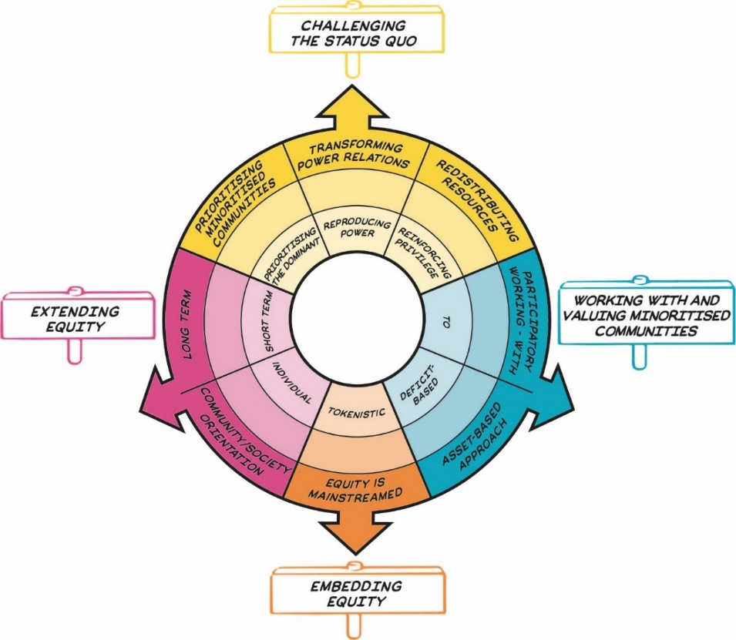
Figure 2: The Equity Compass showing eight dimensions of equity, grouped into four overarching areas represented by signs that sit outside the main circle. Details are presented in Table 1.
The Equity Compass was originally developed and tested in partnership with informal science, technology, engineering and mathematics (STEM) learning settings, such as science centres, zoos and afterschool clubs. It has since been applied by other educators and to funding and policy. This insight was developed as part of the training for STEM Ambassadors (UK) in Spring 2022.

The Equity Compass: How to use it
- By attending to each of the eight dimensions, the Equity Compass can help STEM Ambassadors to better support all participants, but particularly those from minoritised communities.
- The Equity Compass can help you recognise and think about key dimensions of equity/ social justice – and consider how equitable your own practice is. Each axis of the Equity Compass has a set of associated Guiding Questions to help you to reflect on your practice from an equity perspective. For example, where would your current practice, or a specific activity, sit on each axis? Being positioned closer to the outer edges indicates stronger equitable practice.
- The Equity Compass can be used to identify areas that you might like to develop further. For example, you might want to prioritise an area where your mapping sits closer to the centre of the Equity Compass. The Guiding Questions can help prompt the ideas about how future activities could be planned in line with the eight dimensions of equity.
- You could also use the Equity Compass to evidence your progress towards more equitable practice by charting outwards movement on the axes. You could draw or map your current practice on to the Equity Compass and then repeat the exercise at a later point to map change. You could also use the worksheet provided at the end of this insight to record your reflections and plans.
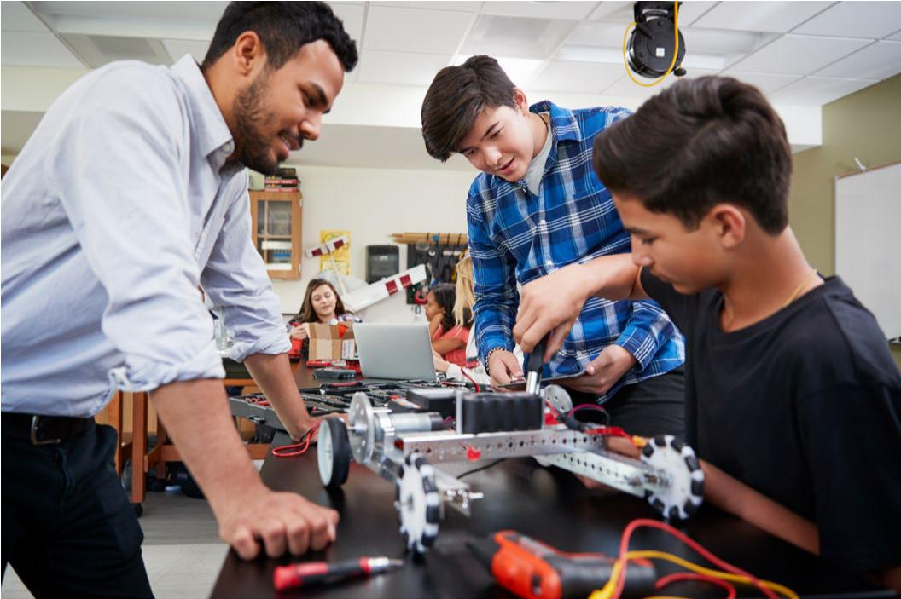
Figure 3: Students and a teacher during a hands-on engineering workshop.

The Equity Compass: Guiding questions for STEM Ambassadors
Table 1: Equity Compass sections and guiding questions
Area | Equity dimension – outer layer of the Equity Compass (strong practice) | Inner layer of the Equity Compass (weak practice) | Guiding questions for STEM Ambassadors
Challenging the status quo | Transforming power relations | Reproducing power | How do you challenge dominant ideas and representations in your session, e.g., scientists as clever, engineers as white men?
Challenging the status quo | Prioritising minoritised communities | Prioritising the dominant | Whose interests, values and needs drive what you do? Those of powerful, dominant groups (e.g., STEM industry, your organisation, the STEM pipeline) or those of minoritised young people and communities?
Challenging the status quo | Redistributing resources | Reinforcing privilege | How is your practice supporting young people who tend to have fewer opportunities? Or are opportunities mostly directed at and reaching people who are already more privileged?
Working with and valuing minoritised communities | Participatory working - with | To | Are sessions being done ‘to’, ‘for’ or ‘with’ minoritised young people and communities? How are young people involved in co-designing the sessions?
Working with and valuing minoritised communities | Asset-based approach | Deficit-based | How are you valuing and recognising young people’s broad range of knowledge, skills and experience in your sessions? Might you inadvertently be treating some young people as ‘lacking’ information, aspiration, interest?
Embedding equity | Equity is mainstreamed | Tokenistic | How central, major, intentional and foregrounded are equity issues in your sessions?
Extending equity | Long term | Short term | Do you tend to do one-off sessions? How might you be able to support longer-term engagement – either through the sessions directly, or by linking with other opportunities?
Extending equity | Community/ society orientation | Individual | How do your sessions support wider outcomes, e.g., for young people’s families and community?

Spotlight on practice: Dr Bridges’ journey to developing more equitable practice as a STEM Ambassador

A typical Dr Bridges session
Dr Bridges (a pseudonym), a white man, is a civil engineer who loves sharing his knowledge and skills with young people. He works as a volunteer STEM Ambassador with several schools across England, where he is usually invited to schools serving relatively affluent communities and/or top set science classes where a number of students have shown interest in engineering careers. He usually begins his sessions by talking about his job and his colleagues (including women engineers); tells the students that arched bridges are stronger than flat bridges and then introduces a practical activity, building lolly stick bridges.
Dr Bridges instructs the children to build one flat bridge and one arched bridge and see how many toy cars are supported on each. At the end of the session, he usually does a quick questions and answers session about engineering careers, seeking to enthuse young people about engineering careers that currently face a shortage of skilled candidates. If he has time left, he likes to tell the students about the contributions that engineers make to improve lives.
Figure 4: Engineer at a construction site, wearing a hard hat and high visibility jacket

Evaluating Dr Bridges’ session
There are a number of good aspects of the sessions. Many of the students enjoy the playful hands-on activity, they increase their engineering content knowledge (learning more about bridges and structural engineering), appreciate a direct experience of meeting a STEM professional (the first such opportunity for some) and enjoy a break from the norm.
However, recent students’ feedback highlighted some problematic areas. The session appeared to reinforce stereotypes about engineers (as one student wrote: “I think an engineer is a man who is good at maths and science and needs to be strong to make stuff.”). The evaluation also showed that students who were not interested in bridges were not very engaged and struggled to connect with the topic of bridges that Dr Bridges was so passionate about (“He was obsessed with bridges! I think he just really loved bridges.”; “It was OK, I guess. But I’m not the most massive fan of bridges.”).

Mapping Dr Bridges’ practice on the Equity Compass
When we mapped Dr Bridges’ session on the Equity Compass, it was evident that his practice ‘sits’ close to the middle (see the figure below), although there were some aspects that were stronger than others. In the table below, we show how each of the eight dimensions were considered.

Spotlight on practice: Dr Bridges’ journey to developing more equitable practice as a STEM Ambassador (cont.)
The table below shows how Dr Bridges’ practice can be mapped using the Equity Compass dimensions.
Table 1: Equity Compass sections and guiding questions
Area | Equity dimension | Reflections on Dr Bridges’ current practice
Challenging the status quo | Transforming power relations | The session largely reproduces and reinforces stereotypical images of engineering and engineers (as male and white), although Dr Bridges mentions that his team includes a few women engineers.
Challenging the status quo | Prioritising minoritised communities | Dr Bridges is motivated by inspiring young people to study engineering because there is a labour market/economic need for more engineers, there is less focus on the needs of the students (he is prioritising the STEM pipeline).
Challenging the status quo | Redistributing resources | Dr Bridges tends to work with top set students and gravitate towards the “keenest” students who tend to be higher achieving, providing them with most support (and he is thus reinforcing privilege).
Working with and valuing minoritised communities | Participatory working - with | Students are not involved in the design or running of the session; the session is largely delivered one-way.
Working with and valuing minoritised communities | Asset-based approach | Dr Bridges asks students about their knowledge of bridges (e.g., what makes a strong bridge), but nothing beyond this that would help students share their experiences of engineering more widely. He focuses on raising interest and aspirations in engineering (deficit approach).
Embedding equity | Equity is mainstreamed | Dr Bridges hasn’t given equity much consideration; treats everyone the same.
Extending equity | Long term | This was a one-off session with little/no signposting to other opportunities.
Extending equity | Community/ society orientation | Dr Bridges makes some references to how engineering helps wider society, but the activity remains largely focused on individual knowledge/skills gains.

Dr Bridges’ ideas for improving his practice
Dr Bridges was initially surprised by the evaluation of his practice from an equity perspective (“all the children seem to enjoy my visits and I’ve never had any complaints. I’m a volunteer, there is only so much I can do.”). On reflection, he admitted that he would like to understand the mapping a bit more:

“I’m keen to see how I can make my sessions more inclusive, particularly for young people who don’t see STEM as being for them After all, the whole point I volunteer as a STEM Ambassador is to help more young people to engage with engineering.”

He also shared that he has been thinking about his own background and privilege:

“I’m a white middle class man and I benefitted from lots of science and engineering family members. Engineering always seemed like quite a natural choice for me. But I can see that not everyone has the same opportunities.”

Below, we share Dr Bridges’ ideas for how he could develop his practice towards becoming more equitable.

Figure 5: Students and a teacher during a hands-on engineering workshop.

Challenging the status quo
My ideas for challenging dominant representations of engineers
- Share relatable examples of diverse engineers.
- Highlight examples of everyday engineering skills that anyone might have, to show how everyone is an engineer, not just professionals.
- Ask the students to share their ideas or designs for things that they would like to design for themselves and their communities.
My ideas for prioritising the interests, needs and values of students
- Ask the students what is important to them.
- Ask the students what social or environmental problems they want engineering to tackle.
My ideas for ensuring the session supports students with fewer opportunities
- Make sure that I am not just visiting affluent schools or only working with top set students.

Working with and valuing minoritised communities
My ideas for co-designing sessions with students
- Find out about the students’ interests and issues they care about, and use these in the session, e.g., I could get in touch with the class teacher beforehand and ask them a bit about the class, what they are like, what they are interested in.
- Consider branching out beyond bridges – maybe I could get the students to design or build their own structures.
My ideas for recognising and valuing young people’s knowledge and experiences
- Make sure I am not just asking factual knowledge questions but elicit the students’ wider life experiences.
- Ensure I value all the students’ suggestions and experiences.
- Help the students to identify the engineering skills they already have (e.g., designing, testing, analysing, measuring) and help them recognise these in their home lives and among people they know.

Embedding equity
My ideas for how to make equity issues more central in my work
- Think about equity as a core point to address in every session, not as a separate topic or an add-on.
- Always plan with equity at the forefront of his mind.
- Plan and reflect on every session using the Equity Compass.

Extending equity
My ideas for supporting young people over time
- Put together links to further resources, websites and organisations that run engineering challenges and give this to the class, so that any interested students have some ‘what next’ ideas.
- Work with the teacher to help them with ideas on an engineering-related activity/project for the students to work on either in class or if there is a STEM club.
My ideas for how to support wider outcomes from the session
- Take photos of the students’ bridges for the school newsletter.
- Invite parents/carers to come and see the bridges, with students’ explaining their work and engineering knowledge and skills used.
- Explore how to extend future sessions, so that the students get to share their own designs for what they want to create for themselves and their communities.

About the YESTEM project
- Over four years, our project involved researchers, ISL educators and young people working in partnership to develop new understandings and insights about how ISL might better support equitable outcomes for young people aged 11-14 from minoritized communities.
- Our project partnership involved data collection in the UK and the USA with partners in two science centres, two community STEM clubs, a zoo and a digital arts centre.
- Overall, 260 young people and 30 practitioners took part.
- In the wider project we also conducted surveys with 2,783 young people (1,873 in the UK and 910 in the US).

Additional resources
- See YESTEM Insight 1: The Equity Compass: A Tool for supporting socially just practice. (informal STEM learning edition)
- See a 2-minute animation explaining the Equity Compass.
- See The Equity Compass: A Tool for supporting socially just practice – Teacher Edition.
- See The Equity Compass worksheet.

Website: yestem.org
Follow on Twitter: @YESTEM_UK

This material is based upon work supported under a collaboration between the National Science Foundation (NSF), Wellcome, and the Economic and Social Research Council (ESRC) via a grant from the NSF (NSF grant no. 1647033) and a grant from Wellcome with ESRC (Wellcome Trust grant no. 206258/Z/17/A)
Disclaimer
Any opinions, findings and conclusions or recommendations expressed in this material are those of the author(s) and do not necessarily reflect the view of NSF, Wellcome, or ESRC.

How to cite this publication: YESTEM Project Team (2022). YESTEM Insight: The Equity Compass: A Tool for supporting socially just practice – STEM Ambassadors Edition. yestem.org

We use the term ‘minoritised’ as a shorthand for individuals and communities who are minoritised by dominant culture/society. Using ‘minoritised’ rather than ‘minority’ puts the emphasis on the systemic issues and structures that are failing to sufficiently recognise, support and value some people. People can be minoritised within a particular society depending on their race/ethnicity, gender, socioeconomic background, dis/ability, sexuality and other social axes. We acknowledge that labels are always imperfect and provisional and can vary in meaning and interpretation over time and between contexts, e.g., internationally, across different professional sectors, communities and between researchers, practitioners and young people.
In England, students are often taught in attainment-based groups, called sets. Top sets are groups composed of the highest attaining students in their year.

