YESTEM Insight (Accessible version)
Original version: https://yestem.org/wp-content/uploads/2022/03/2022-YESTEM-Insight-How-to-set-up-and-run-an-equitable-youth-board.pdf

How to set up and run an equitable youth board

What is the Issue?
- Young people’s voices are often not included in the design of informal STEM leaning (ISL) programmes and experiences.
- There is an increasing recognition of the value and benefits that come from working in participatory ways with young people, particularly with those from communities that are minoritised and excluded by society and by STEM.
- Youth boards (under various names, such as Youth Action Council, Youth Council, Direction Board, Youth Advisory Group, etc.) are one format of working in participatory ways with young people.
- It is important to think about issues of equity and social justice in relation to youth boards because approaches can range from tokenistic or even exploitative to meaningful and equitable.

In this insight, we bring together key ideas about how to set up and run a youth board in a way that is equitable, where dominant power relations are challenged and transformed, where young people are recognised and valued as partners, and where their contributions make a difference to the organisation, shaping its strategy and practice.
This document is intended for informal STEM learning practitioners, organisations and others thinking about participatory practice.

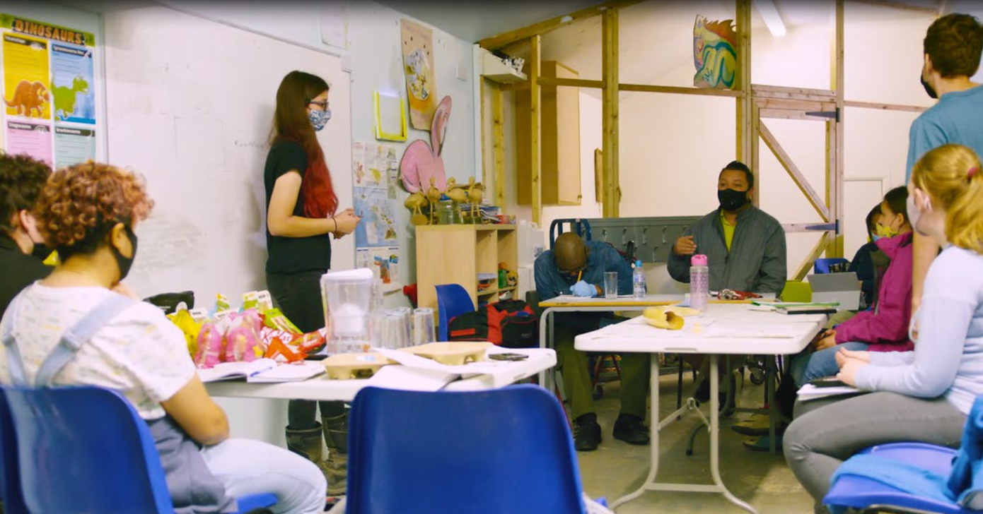
Figure 1: Direction Board meeting at Hanwell Zoo

Tips for setting up and running an equitable youth board

Before you start
- Get a social justice mind set: Develop a sound understanding of what social justice and equity mean and entail. You might find it helpful to read, share and discuss resources such as the Equity Compass and Core Equitable Practices.
- Create a shared vision: Work collaboratively with others within and beyond your organisation to think about the purpose of the youth board. How might your organisation benefit from a youth board? What are the vision and goals of your youth board? How might you involve young people in establishing the vision and goals?
- Get everyone on board: Bring the whole organisation with you so that everyone recognises the value and importance of the board. For a youth board to meaningfully represent youth voices, encourage innovation and drive changes, every department and staff at all levels need to understand and support the youth board. The whole organisation needs to value and take working with young people seriously.

Recruiting the youth board
- Be proactive in your recruitment: Equitable recruitment takes effort and thought – a general advertisement is unlikely to reach and engage young people from communities that are traditionally under-represented in STEM and informal STEM learning (e.g., in relation to race/ethnicity, socioeconomic background, gender, dis/ability, gender identity and sexuality, etc.). Be proactive in how you get the message out – working with other local organisations and gatekeepers who are grounded in these communities can be useful. Listen and take advice on the channels and media that you use – one size rarely fits all! Consider offering a ‘taster’ or ‘find out more’ opportunity for potential applicants and their families.
- Recognise the value and needs of board members: How will you recognise the value, time and work that the youth board put in? Will you pay or reimburse members for their time and travel costs? How will you support participation for a wide range of communities? Communicate clearly during the recruitment process what is provided and take advice on what support particular communities may need to be able to take part.
- Encourage creative application formats: Make the opportunity as widely available and accessible as possible. Applications could be in different formats, not limited to a written form or a cover letter – for instance, applications could take the form of a short video.
- Give feedback to unsuccessful applicants: Ensure a fair and transparent recruitment process and provide constructive feedback to unsuccessful applicants (direct them to future opportunities, where possible).

Running the youth board
- Welcome and care for youth board members: Provide induction and orientation process for new members so they feel welcomed. Provide training and support where appropriate. Ensure that everyone has a chance to get to know each other and understand their roles and responsibilities. Think about how to regularly ‘check in’ with board members.
- Meet everyone’s needs: Co-plan meetings and activities together with young people, at times suitable for them to attend. Put in place mechanisms to catch up on missed meetings. Provide practical support to young people to enable everyone to take part – such as providing refreshments, meeting travel costs, ensuring meetings are accessible to those living with disabilities, etc. Be proactive in identifying what else might be needed to support participation as needs can change.
- Create safe spaces and practices: From the basics (e.g., health and safety, data protection, safeguarding) to more complex and sensitive issues around discussing inequalities and privilege and embedding issues of equity and social justice into everyday practice.
- Work with young people: Ensure that board, roles, expectations and ways of working are co-designed, jointly agreed and clearly communicated. If the board want to have designated roles (e.g., Chairs, Co-Chairs, Treasurers) then work together to co-design the mechanisms to ensure that these are transparent and accessible.
- Value everyone’s voice and contributions: Create an ethos where all young people can share their ideas comfortably and feel that their contributions are being valued. Consider co-creating a ‘code of conduct’ together with the young people.
- Make the board visible: Ensure that the Board has visibility and is included in public-facing materials of the organisastion (while considering data protection and privacy of young people).
- Give the board power and authority: Set up lines of accountability so that youth board’s ideas and suggestions inform the wider organisation and can be actioned. The youth board should be connected to existing structures (e.g., a youth member is a representative to trustees, senior managers being mandated to act and respond). Provide time and space for board members’ feedback to discuss improvements. If possible, give the youth board the resources they need in order to be effective (e.g., designated budget).
- Make it count – support board members’ futures: Provide ongoing support and development opportunities (e.g., support transferable skills, provide mentoring, direct young people to other to relevant opportunities).

Figure 2: Youth board (US)

Spotlight on practice: Youth Council at Knowle West Media Centre (UK)
Knowle West Media Centre, who run a range of programmes for young people, have long had a strong focus on equitable and participatory practice. For instance, they regularly sought young people’s views and suggestions about the activities, to make sure the organisation is meeting the needs of the local young people.
Recently, the organisation decided to start a Youth Council to involve young people in a more formal and structured way. The young people were recruited from ongoing programmes, through being actively encouraged to come along to the Council meetings and share their views (See Tip #4: Be proactive in your recruitment). The Youth Council is open to everyone, and young people are free to drop in without having to commit to the participation long-term – this way, the practitioners are able to ensure that a broad range of voices is represented. As Dot, one of the practitioners, put it: “having an open-door policy allows us to hear more voices”, adding that such approach has helped them be more equitable and not exclude young people who might not be able to commit long term.
As young people join the Youth Council at different times, the facilitators ensure that everyone feels welcome. Facilitators make sure that the young people feel they are allowed to be there, even if they have not been there before, using ice breaker activities at the beginning of the sessions and ensuring that everyone has names and pronouns on their badges (See Tip #8: Welcome and care for youth board members).
The Youth Council would discuss things like activities for the next term’s programme. With some suggestions being more feasible to realise than others, the practitioners ensure that all of the ideas are heard and responded to (See Tip #14: Give the board power and authority). For instance, while it is not always possible to accommodate every suggestion, it is important to hear and address these, which includes talking to young people about why some ideas might not be feasible at the time and what else they might be able to do instead.
“Young people have really good ideas; they are inspiring to talk to. This makes our work easier and more enjoyable.” (Practitioner)
Over time, the Youth Council has become a permanent and visible feature of Knowle West Media Centre as well as within the wider local community (See Tip #13: Make the board visible). The group has been instrumental in informing the themes that guided the activities, such as the focus on the environment, mental health and wellbeing, and celebrating the community. The facilitators also agreed that, overall, working with the Youth Council has made their work easier and more enjoyable – and they feel more comfortable that they are indeed responding to the needs and interests of the community. Young people, too, felt that their contributions were making a difference.
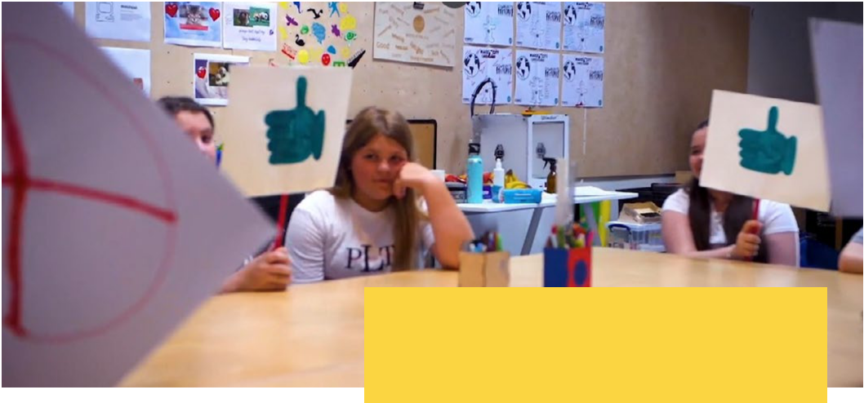

Spotlight on practice: Youth Action Council at the Impression 5 (US)
Impression 5 Science Center noticed that they were losing participation in programmes among youth ages 12 and up. They were also concerned that the membership of the science center did not reflect the demographics of their city. The membership was whiter and more affluent than the city itself.
The leadership team discussed many different ideas for how to foster interest in the Science Center for older youth and youth of colour (See Tip #2: Create a shared vision and Tip #3: Get everyone on board). One idea they had was to build a new makerspace so that older youth could work independently on projects they cared about. As they began to plan for the makerspace, they knew that if the space was to be attractive to youth, they needed to include them authentically in the design process (See Tip #14: Give the board power and authority). Center leaders paused the design process until they could get a Youth Action Council, or YAC, up and running.
Designing and recruiting for the YAC involved many intentional steps. Several planning sessions were held among various stakeholders in the Science Center community and input was also sought from parents. Once the YAC was in place, Science Center educators worked with youth to co-plan activities and experiences.
Center leadership also sought to ensure the YAC reflected the city’s diversity, racially and economically. In addition to publicising the new YAC on the Center’s social media to garner interest, educators also reached out to community organisations and school districts to get the word out. Center membership was offered to the families of YAC members. Bus passes and help with organising transportation was provided to those youth who needed it (See Tip #4: Be proactive in your recruitment).
When the makerspace was completed, the Science Center organised a grand opening to recognise the young people’s work (See Tip #13: Make the board visible). In a speech delivered to the press and supporters, YAC member Jay gave the following speech:
“The YAC is a group of kids who want to inspire other kids on making. We are a group of 9-year-olds and up. We had many meetings to help design activities and give feedback. We also gave ideas for what the space needed to look like - VERY COLORFUL! We designed the room to be a place where we can be inspired, and have fun. When we started this off this was just a room full of dust. We built the space for other kids to innovate and be creative.”
The YAC’s work extended beyond the design of the makerspace as youth brought in new ideas and concerns. For example, they challenged the Center to become less male and less white, and to incorporate more signage, imagery and experiences that reflected their lives and interests. These challenges led to new YAC projects, such as the design of the Katherine Johnson room (See Tip #11: Work with young people). This work involved conversations about racism and experiences of discrimination, which made some YAC members uncomfortable. Micaela, who led many of these conversations, ensured that everyone was listened to and heard, and that the group was respectful and empathetic to different experiences and perspectives (See Tip #10: Create safe spaces and practices).
“You need to make sure the activities allow kids to solve the problems they care about, and that we feel like we can solve those problems here.” (Youth Action Council member)

About the YESTEM project
- Over four years, our project involved researchers, ISL educators and young people working in partnership to develop new understandings and insights about how ISL might better support equitable outcomes for young people aged 11-14 from minoritized communities.
- Our project partnership involved data collection in the UK and the USA with partners in two science centres, two community STEM clubs, a zoo and a digital arts centre.
- Overall, 260 young people and 30 practitioners took part.
- In the wider project we also conducted surveys with 2,783 young people (1,873 in the UK and 910 in the US).

Additional resources
- See YESTEM Insight 1: The Equity Compass: A Tool for supporting socially just practice. (informal STEM learning edition) and YESTEM Insight 2: What are Core Equitable Practices in informal STEM learning?
- See a short film about the Direction Board at Hanwell Zoo.

We want to thank young people from four youth boards who contributed to and reviewed this insight:
- Direction Board at Hanwell Zoo (UK)
- Youth Council at Knowle West Media Centre (UK)
- Youth Action Council at Impression 5 (US)
- Youth Teen Leaders at the Boys & Girls Club of Lansing (US)

Website: yestem.org
Follow on Twitter: @YESTEM_UK

This material is based upon work supported under a collaboration between the National Science Foundation (NSF), Wellcome, and the Economic and Social Research Council (ESRC) via a grant from the NSF (NSF grant no. 1647033) and a grant from Wellcome with ESRC (Wellcome Trust grant no. 206258/Z/17/A)
Disclaimer
Any opinions, findings and conclusions or recommendations expressed in this material are those of the author(s) and do not necessarily reflect the view of NSF, Wellcome, or ESRC.
How to cite this publication: YESTEM Project Team (2022). YESTEM Insight: How to set up and run an equitable youth board. yestem.org

