YESTEM Insight (Accessible version)
Original version: https://yestem.org/wp-content/uploads/2022/03/Equity-Compass-for-teachers.pdf

The Equity Compass: A tool for supporting socially just practice – Teacher edition

What is the Issue?
- Inequity is an ongoing and important issue for schools. Research shows the impact of injustices on students’ experiences, attainment, progression and well-being.
- At the same time, many teachers have limited support and training to address the complexity of inequalities.
‘I looked at our inclusion policy and apart from one exception, equity isn’t really a focus. That made me think more than ever that maybe I’m not the only one who hadn’t given it enough consideration.’ (Primary school teacher)

Whereas equality means treating everyone the same and providing everyone the same opportunities, an equity approach advocates for differential treatment of people according to need, while also recognising and valuing differences between people. A social justice approach seeks to change the structures and practices that create and maintain inequalities.
Figure 1: Students in a classroom

The Equity Compass: A tool for supporting socially just practice
- The Equity Compass is a tool that can help primary and secondary teachers and any support staff to reflect on and develop their teaching, adopting a social justice mind set. The tool aims to support teachers towards inclusive and socially just practice in relation to all areas of injustice and protected characteristics, including race, gender, sexual orientation, social class, disability, religion, etc.
- Adopting an equitable teaching approach is not just about what you do, but how and why you do it. The stance taken and the principles underlying a teaching approach can profoundly shape its potential for either reinforcing, or transforming, social inequalities. The Equity Compass can support teachers to consider multiple dimensions of equity, as represented by the eight dimensions of the Compass
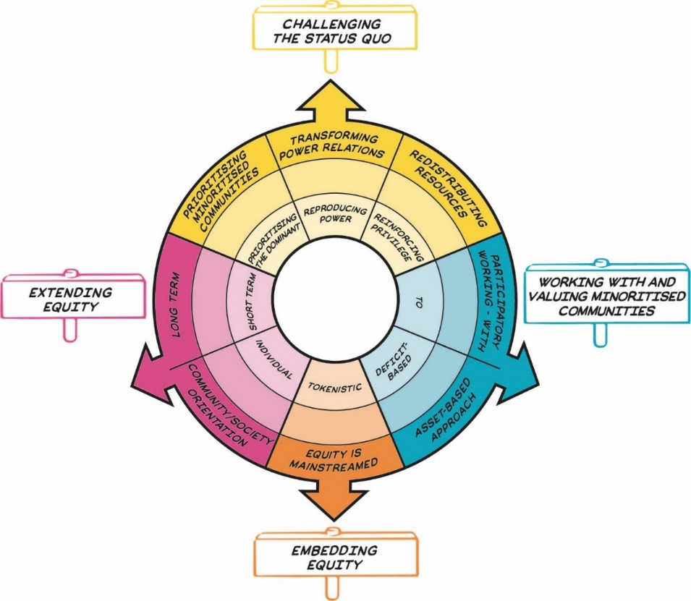
Figure 2: The Equity Compass showing eight dimensions of equity, grouped into four overarching areas represented by signs that sit outside the main circle. Details are presented in Table 1.
The Equity Compass was originally developed and tested in partnership with informal science, technology, engineering and mathematics (STEM) learning settings, such as science centres, zoos and afterschool clubs. It has since been applied by teachers and other educators more broadly (in primary and secondary schools, colleges and a range of informal learning settings), to the teaching of all subjects, and to educational funding and policy. The initial version of the Equity Compass included eight separate dimensions (axes) of equity; the version presented here was co-developed further with primary and secondary teachers, resulting in grouping the eight axes into four overarching areas.

The Equity Compass: How to use it
- By attending to each of the eight dimensions, the Equity Compass can help teachers to better support all students, but particularly those from minoritised communities.
- Each axis of the Equity Compass has a set of associated Guiding Questions to help you to reflect on your teaching from an equity perspective. For example, where would your current teaching, or a specific activity, sit on each axis? Being positioned closer to the outer edges indicates stronger equitable practice.
- The Equity Compass can be used to identify areas that you might like to develop further. For example, you might want to prioritise an area where your mapping sits closer to the centre of the Equity Compass. The Guiding Questions can help prompt the ideas about how future teaching could be planned in line with the eight dimensions of equity.
- You could also use the Equity Compass to evidence your progress towards more equitable practice by charting outwards movement on the axes. You could draw or map your current practice on to the compass and then repeat the exercise at a later point to map change (see an image below that shows how one of the teachers mapped her lesson on the compass). You could also use the worksheet provided in this insight to record your reflections and plans.
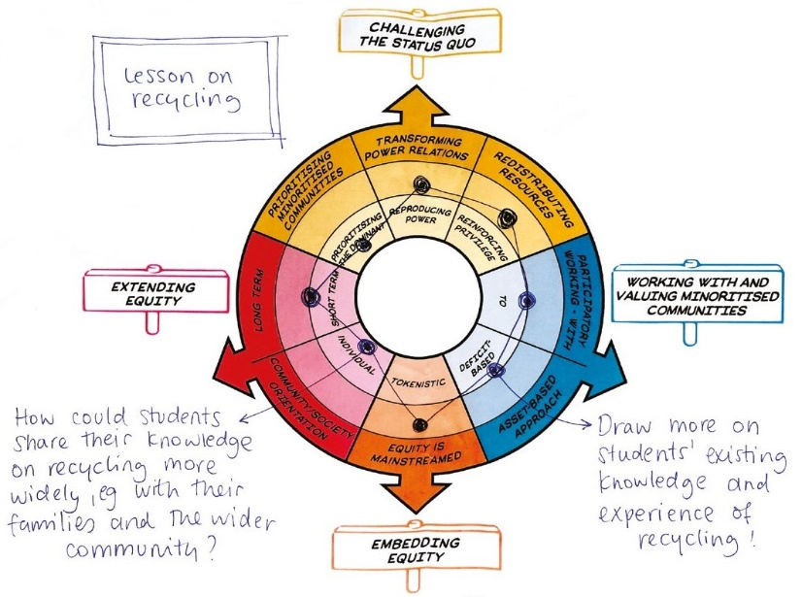
Figure 3: An example of how one teacher mapped her lesson on the Equity Compass, adding her plans for further development of her practice

How to adopt the Equity Compass at your school
- The Equity Compass can be used to consider anything from a school-wide programme, the curriculum, to an individual lesson or a specific activity
- This tool is designed to be a formative, not summative, tool to support honest, on-going reflection. It is not about trying to get a ‘perfect score’ or ticking off areas as ‘done’. Developing equitable practice is an on-going process.
- The Equity Compass could be used by teachers independently. However, it would be particularly effective to use it together with colleagues or as part of a structured professional development. For example, the tool could be championed by diversity and inclusion coordinators, used as part of professional development during in-service training (INSET) days or be a focus of a working group.
- Using the Equity Compass would be particularly valuable for newly qualified teachers and as part of initial teacher education or training programmes.
- Working with the Equity Compass can sometimes feel uncomfortable because it asks us to identify inequitable power relations and address privilege. However, these feelings can be useful and productive, and can indicate that the tool is being used in a reflective way. We would suggest that teachers—particularly those from dominant, privileged social groups—acknowledge and work with any feelings of discomfort and remember that these feelings can be useful (i) as a cue to remind you to foreground, listen to and learn from the experiences of others and (ii) to help collaboratively identify new ways forward.

The Equity Compass: A tool for supporting socially just practice
Table 1: Equity Compass sections and guiding questions
Area | Equity dimension – outer layer of the Equity Compass (strong practice) | Inner layer of the Equity Compass (weak practice) | Guiding questions for teachers and support staff
Challenging the status quo | Transforming power relations | Reproducing power | Do students from minoritised communities feel that their school is a place where injustice in all forms (e.g., racism, sexism, ableism, class and LGBTQI+ prejudice, and so on) are being addressed and challenged?  What opportunities are there for dialogue about power relations? How are students from more privileged communities supported to constructively understand and address their privilege and how their privilege impacts others?  To what extent are ‘dominant’, hierarchical power relations between teachers and students, or between more privileged (White, middle class) students and less privileged (minority ethnic, migrant, working class) students being reproduced, or disrupted and transformed in your classroom and at your school?
Challenging the status quo | Prioritising minoritised communities | Prioritising the dominant | Whose interests, needs and values drive your teaching and the curriculum – those of the ‘dominant’ groups (e.g., school leadership, industry, economy, and privileged students) or those of students from minoritised communities?  To what extent do you meet wider needs of minoritised students (e.g., hunger, safety) necessary for them to learn and engage?
Challenging the status quo | Redistributing resources | Reinforcing privilege | How are minoritised students being supported in gaining resources (e.g., knowledge, skills, social networks, and chances)?  Are opportunities predominantly directed at more privileged students, thereby reinforcing privilege? For example, do ‘top set’ students tend to get more opportunities?  How do you understand the reasons for different outcomes between groups of students? For example, do you talk about learning and attainment ‘gaps’ or ‘debts’?
Working with and valuing minoritised communities | Participatory working - with | To | How participatory is your teaching/curriculum? Is teaching being primarily done ‘to’ and ‘for’ students, or are there opportunities to work ‘with’ students, particularly those from minoritised communities (e.g., to co-design activities and projects)?  To what extent are minoritised students given opportunities to be recognised as producers of the knowledge/learning (not just consumers)? Who has ownership and voice within the learning?
Working with and valuing minoritised communities | Asset-based approach | Deficit-based | How are you valuing minoritised students’ identities, cultural, experiential and home knowledge and experiences in your teaching? Might some knowledge and experiences get valued more than others?  Are minoritised students’ interests, knowledge, behaviours, identities and resources being recognised and valued (i.e., an ‘asset-based’ approach)? Are some minoritised students treated as lacking the ‘right’ interests, knowledge, behaviours, identities and resources (i.e., a ‘deficit-based’ approach)?
Embedding equity | Equity is mainstreamed | Tokenistic | How mainstreamed, intentional and foregrounded are equity issues at your school? Are equity issues everyone’s core business or are they minor, tokenistic and peripheral concerns (e.g., restricted to special programmes or a few passionate teachers)?  Are equity issues embedded across all school practices, e.g., in time tabling, tutoring and family liaison and in one-off, occasional and extra curricula offers? For example, how are equity values considered, shared with and practised by school visitors and through drop down days, school visits, etc.?
Extending equity | Long term | Short term | Are specific equity initiatives and experiences (e.g., diversity awareness events, diversity ‘celebrations’, careers education, mentoring, role-models, extracurricular clubs and school visits) one-off, short term, or longer-term?  How does the school track the whole student experience to monitor equity issues and the impact of equity work?
Extending equity | Community/ society orientation | Individual | To what extent does your teaching predominantly support the outcomes of specific, individual students? Does it also support more collective, community-oriented outcomes?

Spotlight on practice
Below are two examples from teachers who adopted the Equity Compass in their practice.

Using the Equity Compass to develop equitable teaching in a primary English class
A teacher in a multi-lingual London primary school used the Equity Compass to reflect on and develop her practice towards better supporting the minoritised students in her class.
She observed that her class was usually dominated by a handful of confident students, who would regularly share their experiences from extracurricular activities, trips with their families and knowledge of English literature they read at home. Other students, particularly some for whom English was not their first language, contributed less frequently. On reflection, the teacher realised that she sometimes interpreted these students as being less interested, having lower ability in the subject and as lacking a rich literary home environment. She also noted the absence of Black authors from the reading list.
Using the compass, she decided to take a more asset-based approach, to find out more about the children’s lives and what they enjoyed reading, in both English and other languages and to value and integrate this into lessons. The next day, the teacher invited two usually quiet children to share their experiences and views as much as possible, encouraging them to share any folk tales or stories that they liked, “from either English or your own languages”. After some initial reticence, the children engaged enthusiastically and the whole class enjoyed learning from one another.
A primary teacher reflected on the lesson afterwards: “I was surprised what a difference could be made by such a small thing. You could see the pleasure on their faces that everyone was interested in their knowledge and views.”
The teacher started to plan how she might involve the children (through participatory working) to conduct an audit of library and reading books with a view to refreshing the collection to make it more diverse, inclusive and representative of their identities, interests and lives (prioritising minoritised communities).

Using the Equity Compass to support secondary school students’ engagement with engineering
A teacher from a large, predominantly White British, working-class secondary school in the North of England shared an example of how they used the Equity Compass to rethink the annual ‘career talk’ given by a civil engineer who works at the local construction company to their Year 10 (students aged 14-15) science class. The engineer was an older White man, who would usually arrive at the school wearing his construction hat.
Using the Equity Compass, the teacher noted that the visits might be reinforcing stereotypical images of engineers (as white men in construction hats). Thinking about ways to disrupt power relations, the teacher discussed with the engineer how he might include a discussion about the diversity challenges in the sector and include broader representations of engineering and engineers – sharing some biographical profiles of Black and female engineers.
The teacher reflected how these sorts of career talks were typically one-off, isolated events and decided to think about how they could more regularly connect the science content in the curriculum to their students’ lives, interests and futures as a longer-term approach.
They also reflected on how most STEM enrichment opportunities and interventions tended to be offered to top set students and/or those perceived by staff as being ‘the most interested’, who tended to be those from more privileged backgrounds. They decided to raise the issue at the next department meeting, with a view to forming a working group to develop a more inclusive approach aimed at redistributing resources. The conversation generated a lot of interest, both in the idea and the tool, resulting a few months later in the teacher being invited to share the Equity Compass and the department’s work at the next whole school INSET day, to develop a schoolwide approach to work towards embedding equity.

About the YESTEM project
- Over four years, our project involved researchers, ISL educators and young people working in partnership to develop new understandings and insights about how ISL might better support equitable outcomes for young people aged 11-14 from minoritized communities.
- Our project partnership involved data collection in the UK and the USA with partners in two science centres, two community STEM clubs, a zoo and a digital arts centre.
- Overall, 260 young people and 30 practitioners took part.
- In the wider project we also conducted surveys with 2,783 young people (1,873 in the UK and 910 in the US).

Additional resources
- See YESTEM Insight 1: The Equity Compass: A Tool for supporting socially just practice. (informal STEM learning edition)
- See a 2-minute animation explaining the Equity Compass.
- We want to thank the research team and teachers working on the Primary Science Capital Project, who have provided valuable feedback and examples for this insight. Visit the Primary Science Capital Project website www.ucl.ac.uk/ioe/PrimarySciCap and follow them on Twitter @PrimarySciCap for primary school resources.

Website: yestem.org
Follow on Twitter: @YESTEM_UK

This material is based upon work supported under a collaboration between the National Science Foundation (NSF), Wellcome, and the Economic and Social Research Council (ESRC) via a grant from the NSF (NSF grant no. 1647033) and a grant from Wellcome with ESRC (Wellcome Trust grant no. 206258/Z/17/A)

Disclaimer
Any opinions, findings and conclusions or recommendations expressed in this material are those of the author(s) and do not necessarily reflect the view of NSF, Wellcome, or ESRC.

How to cite this publication: YESTEM Project Team (2021). YESTEM Insight: The Equity Compass: A Tool for supporting socially just practice – Teacher Edition. yestem.org

We use the term ‘minoritised’ as a shorthand for individuals and communities who are minoritised by dominant culture/society. Using ‘minoritised’ rather than ‘minority’ puts the emphasis on the systemic issues and structures that are failing to sufficiently recognise, support and value some people. People can be minoritised within a particular society depending on their race/ethnicity, gender, socioeconomic background, dis/ability, sexuality and other social axes. We acknowledge that labels are always imperfect and provisional and can vary in meaning and interpretation over time and between contexts, e.g., internationally, across different professional sectors, communities and between researchers, practitioners and young people.

