YESTEM Insight (Accessible version)
Original version: https://yestem.org/wp-content/uploads/2022/03/Equity-Compass-for-school-leaders-and-governors.pdf

The Equity Compass: A tool for supporting socially just practice – School Leaders and Governors Edition

What is the Issue?
- Inequity is an ongoing and important issue for schools. Research shows the impact of injustices on students’ experiences, attainment, progression, opportunities and well-being.
- Injustices are also an issue for school staff. In the UK, teaching remains a predominantly White profession, even in urban schools serving diverse communities. Black and Minority Ethnic staff also remain under-represented in school leadership positions and the already chronic under-representation of BAME school governors continues to worsen.
- School governing bodies and school leadership teams are tasked with ensuring clarity of vision, ethos and strategic direction. Governing boards need to be inclusive of and responsive to the communities they serve. At present, school leaders and governance bodies have limited support, tools and training to address the complexity of social inequalities.
Whereas equality means treating everyone the same and providing everyone the same opportunities, an equity approach advocates for differential treatment of people according to need, while also recognising and valuing differences between people. A social justice approach seeks to change the structures and practices that create and maintain inequalities.

Figure 1: Three adults in a meeting

The Equity Compass: A tool for supporting socially just practice
- The Equity Compass is a tool that can help school leadership to reflect on and develop their vision, strategic priorities and the school development plan by adopting a social justice mind set. The tool aims to support school leadership towards inclusive and socially just practice in relation to all areas of injustice and protected characteristics, including race, gender, sexuality, social class, disability, religion.
- Adopting an equitable approach in school leadership is not just about what you do, but also how and why you do it. The stance taken and the values and principles that drive school leaders profoundly shape the school’s culture, direction and practice, shaping the potential for either reinforcing, or transforming, social inequalities. The Equity Compass can support school leadership to consider multiple dimensions of equity, as represented by the eight sub-dimensions of the Compass, which are grouped into four overarching areas.
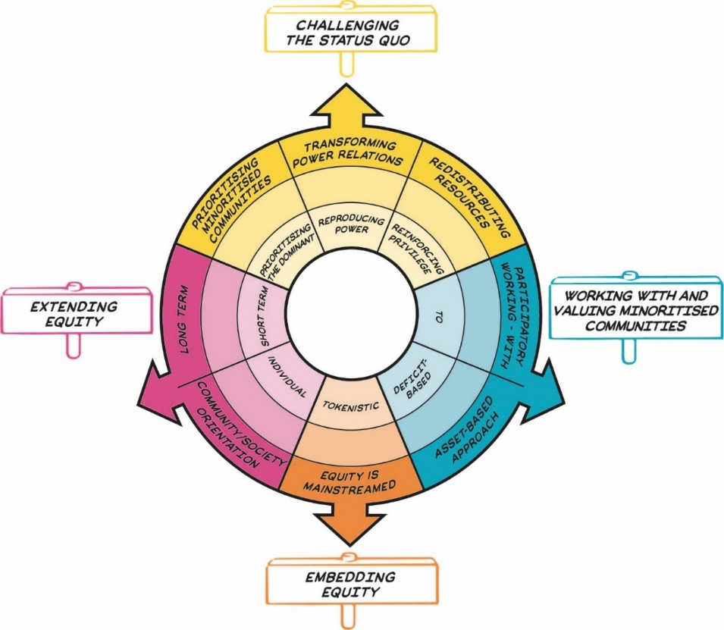
Figure 2: The Equity Compass showing eight dimensions of equity, grouped into four overarching areas represented by signs that sit outside the main circle. Details are presented in Table 1.
The Equity Compass was originally developed and tested in partnership with informal science, technology, engineering and mathematics (STEM) learning settings, such as science centres, zoos and afterschool clubs. It has since been applied by teachers and other educators more broadly (in primary and secondary schools, colleges and a range of informal learning settings), to the teaching of all subjects, and to educational funding and policy. The initial version of the Equity Compass included eight separate dimensions (axes) of equity; the version presented here was co-developed further with teachers, governors and school leaders, resulting in grouping the eight axes into four overarching areas.

The Equity Compass: How to use it
- By attending to each of the dimensions, the Equity Compass can help governors and school leaders to reflect and plan in order to better support all staff and students, but particularly those from minoritised communities.
- Each axis of the Equity Compass has a set of associated Guiding Questions to help you reflect on the school culture, vision, values and current development planning from an equity perspective. For example, where would a particular strategic objective sit on each axis? Being positioned closer to the outer edges indicates stronger equitable practice.
- The Equity Compass can be used to identify areas that you might like to develop further. For example, you might want to prioritise an area that your mapping has identified as currently sitting closer to the centre of the Equity Compass. The Guiding Questions can help prompt ideas about how strategic objectives, resource allocations and accountabilities could be planned in line with the various dimensions of equity.
- You could also use the Equity Compass to evidence your progress towards more equitable practice by charting outwards movement on the axes. You could draw or map your current indicators of school culture on to the compass and then repeat the exercise at a later point to map change.
- Working with the Equity Compass can sometimes feel uncomfortable because it asks us to identify inequitable power relations and address privilege. However, these feelings can be useful and productive, and can indicate that the tool is being used in a reflective way. We would suggest that governors and school leaders—particularly those from dominant, privileged social groups—acknowledge and work with any feelings of discomfort and remember that these feelings can be useful (i) as a cue to remind you to foreground, listen to and learn from the experiences of others and (ii) to help collaboratively identify new ways forward.

How to adopt the Equity Compass at your school
- The Equity Compass can be used to consider anything from the clarity of vision, ethos and strategic direction of your school, to setting objectives to hold executive leaders accountable, and reviewing robust data indicators of engaging students, staff, and the wider community.
- This tool is designed to be a formative, not summative, tool to support honest, on-going reflection. It is not about trying to get a ‘perfect score’ or ticking off areas as ‘done’. Developing equitable practice is an on-going process.
- The Equity Compass could be used independently. In the context of governance, it is particularly powerful to use it together with colleagues or as part of ongoing conversations and structured professional development. For example, consider the data that is used to review school performance objectives and review this with the Equity Compass. Are there any gaps where the governors have none, little or poor-quality evidence of how the school works with and values minoritised communities?
- Using the Equity Compass would be particularly valuable for new governors and the school leadership group as part of the induction process and/or training programmes.

The Equity Compass: How to use it

School leaders
- The Equity Compass can be used to help frame and reflect on the culture of your school – both where it currently is and where you want it to be. It can support the planning, implementation and evaluation of school development and improvement, including planning and submissions for equality charter mark schemes, e.g., Race and Conscious Equality (RACE) Charter Mark, Gender Action, etc.
- The tool can help you reflect on how the whole school systems, events and structures could be made more equitable (e.g., student councils, careers education resources and events, visits to universities, drop down days, timetabling, staff cover processes, behavioural policy and practices, homework policy and practice).
- The Equity Compass can also be used to consider what resources are necessary, and advocate for these to support professional development of school staff to understand and engage with equity issues. Interventions could be framed by considering to what extent equity issues and training feature in staff annual review and target setting in promotion criteria.
- This tool can also inform the development of a plan of action to diversify and support a more diverse and inclusive body of teachers and support staff.
- The Equity Compass can help you think about how to assess the impact of efforts and interventions that aim to support equity – e.g., to what extent can we see an equitable impact from particular interventions or professional development sessions?

School governors
- The Equity Compass can be used to critically review the school’s vision and values through an equity lens and the extent to which these are articulated and evidenced in policy and practice. It can also support planning and action to address injustices. Using the tool can help foreground equity issues within a school’s strategy, culture and practice. It can also be used to consider the extent to which equity features within performance measures for governors and senior staff.
- The tool can support reflection and planning around school staff development, including in relation to resource allocation.
- Governors can use the Equity Compass to evaluate policies in relation to equity and social justice, and consider what evidence is used to make judgements about school performance and activity.
- Finally, the Equity Compass can also help school governors to advocate for and support professional development of governors to understand equity issues, reflect and plan how to encourage more representative governing/trust bodies, and consider how effectively they engage with stakeholders on equity issues.

The Equity Compass: A tool for supporting socially just practice
Table 1: Equity Compass sections and guiding questions
Area | Equity dimension – outer layer of the Equity Compass (strong practice) | Inner layer of the Equity Compass (weak practice) | Guiding questions for school leaders and governors
Challenging the status quo | Transforming power relations | Reproducing power | To what extent is this school a place where all students and staff (but particularly those from minoritised communities) feel that injustice in all forms (e.g., racism, sexism, ableism, class and LGBTQI+ prejudice, and so on) is being addressed and challenged?  How are governors, students and staff from more privileged communities supported to constructively understand and address their privilege and how their privilege impacts others?  To what extent are policies and practices in place that challenge ‘dominant’, hierarchical power relations between teachers and students, and between more privileged (e.g. White, middle class) and less privileged (e.g. minority ethnic, migrant, working class) community members? To what extent can we evidence that social injustices are being reproduced, disrupted or transformed by the school’s and governing body’s values, practices and strategy?
Challenging the status quo | Prioritising minoritised communities | Prioritising the dominant | How does curriculum address the issues of equity and social justice? Is there a positive culture of healthy and respectful critique and rebuttal in considering whose interests, needs and values drive the school’s strategy, teaching and curricula – those of powerful (e.g., school leadership, industry, government) and socially privileged communities (e.g., white, male, heterosexual, able-bodied, etc.) or those from minoritised communities? Are these conversations allowed, encouraged and actively nurtured?  To what extent does the school meet the wider needs of minoritised members (e.g., hunger, safety) that are necessary for them to teach, learn and participate fully in school life?  When, where and how are students (and particularly those from minoritised backgrounds) and staff given opportunities for feedback on their experiences in the classroom, and in other places in the school environment (e.g., mealtimes, playing fields, and arrival and exit experience, including the school bus)? What processes are in place for acting on feedback and reporting back to students, staff and governors?
Challenging the status quo | Redistributing resources | Reinforcing privilege | How are minoritised students and staff being supported in gaining  resources?  Are opportunities predominantly directed at more privileged students, thereby reinforcing privilege? For example, do ‘top set’ students tend to get more opportunities? Are some staff, students or classes (and not others) invited to participate in certain activities, opportunities and events? On what basis? How equitable are the decisions (and decision-processes) regarding who has access to what?  How do school leaders understand the reasons for different outcomes between groups of students? For example, do you talk about learning and attainment ‘gaps’ or ‘debts’?
Working with and valuing minoritised communities | Participatory working - with | To | How participatory is the school development plan process? Is the work of governors and senior leadership team primarily being done ‘to’, ‘for’ or ‘with’ teachers, wider school staff, students and their families? Are there opportunities to work ‘with’ others and to co-design policies, practices and systems, particularly those from minoritised communities?  To what extent do school staff and families/carers, particularly those from minoritised communities, feel that they are meaningful and respected partners, with an important presence in the school community?  Does the school have ‘rights and responsibilities’ policies and practices and to what extent are these developed ‘for’ or ‘with’ students?
Working with and valuing minoritised communities | Asset-based approach | Deficit-based | How is the school valuing minoritised students’ and staff’s identities and experiences? How might some knowledge and experiences get valued more than others?  Does the school vision and values adopt an ‘asset-based’ approach? For example, are minoritised students’ and staff’s identities and experiences being recognised and valued through everyday school life (both in and beyond classroom learning)? Are some students and staff seen or treated as lacking the ‘right’ interests, knowledge, behaviours, identities and resources (i.e., a ‘deficit-based’ approach)?
Embedding equity | Equity is mainstreamed | Tokenistic | How mainstreamed and intentional are equity issues in the school community, including the leadership and governance bodies? Are equity issues everyone’s core business, threaded through all strategy, policy and practice – or are they minor, tokenistic and peripheral concerns (e.g., restricted to special programmes or a few passionate individuals)?  Are equity issues embedded across all school practices, e.g., in time tabling, tutoring and family liaison and in one-off, occasional and extra curricula offers? How is this monitored? What is the impact?
Extending equity | Long term | Short term | Are specific equity initiatives and experiences (e.g., diversity awareness events, diversity ‘celebrations’, careers education, mentoring, role-models, extracurricular clubs and school visits) one-off, short term, or longer-term? How can we tell if these are having an equitable impact?  How does the school track the whole student experience to monitor equity issues and the impact of equity work?
Extending equity | Community/ society orientation | Individual | To what extent might school leaders’ actions and behaviours predominantly support the outcomes of specific, individual staff? How might it also support more collective, community-oriented outcomes?  How might school leaders’ actions and behaviours have equity implications for school ethos and the wider field of school teaching and learning?

Figure 3: Two adults in a meeting

Spotlight on practice

Embedding equity within a primary school
The primary school in South West England prided itself on its inclusivity and providing all children with what they needed to succeed though taking a whole child approach. Despite the ongoing commitment to being inclusive, the Chair of Governors recently raised questions about how equitable practice was embedded throughout the school (e.g., Do we have a social justice mindset? Do we think about inclusivity and socially just practice in relation to all areas, or mostly in relation to special educational needs and behavioural diversity?).
Governors and leaders felt that they are in the privileged position to drive systemic change through whole school approaches and policies; they set the vision and ethos of the school and shape practice, such as through leadership appointments, school development plans, and the general oversight.
The disruption to teaching and learning arising from the Covid pandemic in 2019 had highlighted disadvantages in the school, resulting in the review of the school’s values and principles. The senior leadership team used the Equity Compass as i) a prompt for checking and balancing their shared priorities, and ii) as a tool for developing their equitable practice and exploring better ways of meeting their ambitions in terms of equity.
As a result of the Equity Compass reflections, they developed a specific strategic priority on challenging the status quo that embraces diversity and fosters a positive and inclusive environment where inequities of all kinds are challenged, along with the focus on embedding a long-term approach to implementing equity initiatives.
The team developed a framework to record progress towards more equitable practice within the school, starting with the reflection on the current state and detailing their desired goals. One of the desired goals was to develop their participatory working with the wider school community, including the community of staff, parents and pupils, and together develop strategic planning. Finally, as well as setting and monitoring performance indicators relating to the Equity Compass dimensions for the school, their also agreed to include equity in performance management for all school staff, ensuring that equity is mainstreamed and everyone’s responsibility.
Figure 4: Pupils and teachers in a classroom

Championing the Equity Compass to start an equity journey and challenge the status quo
A parent governor in a multi-lingual North London Comprehensive School was introduced to the Equity Compass by a friend from who works at University College London. At the next governors meeting she took the opportunity to outline the origins of Equity Compass as a tool of social justice and describe how it was being used in informal science learning. The meeting mandated a small working group to investigate and report back on the utility and relevance of the Equity Compass tool for the three core functions of governance:
- Ensure clarity of vision, ethos and strategic direction of the school;
- Hold the headteacher to account for the educational performance of the school and its students, and the performance management of staff;
- Oversee the financial performance of the school and make sure its money is well spent.
The working group recognised that many of the governors lived in the school catchment area while most of the leadership group and staff did not. The working group noticed that the school leadership group interpreted strategy statements on equity and social justice as separate from, and unrelated to, generalised indicators for improving school performance. The group observed that, at times, this was removed from context in which the student lived, and staff worked. For example, performativity pressures were used to justify gaps where the governors were given little or poor-quality data on how the school works ‘with’ and values different minoritised communities. On reflection, the working group concluded that while equity and social justice was evident in the school vision statement, the operationalisation of school performance was not aligned with the vision. In effect, this situation was both reproducing power relations and prioritising the dominant.
As an immediate action, the working party advocated using a forthcoming governing body ‘away day’ to collectively use the Equity Compass to reflect on the alignment between school vision, the school improvement plan and validity of data indicators in order to bring equity issues more centrally into the school’s strategic vision and planning. School leaders recognised that they were at the start of their journey and planned to both continue and extend their efforts to ensure that equity becomes more embedded across policy and practice.
Figure 5: Two students

About the YESTEM project
- Over four years, our project involved researchers, ISL educators and young people working in partnership to develop new understandings and insights about how ISL might better support equitable outcomes for young people aged 11-14 from minoritized communities.
- Our project partnership involved data collection in the UK and the USA with partners in two science centres, two community STEM clubs, a zoo and a digital arts centre.
- Overall, 260 young people and 30 practitioners took part.
- In the wider project we also conducted surveys with 2,783 young people (1,873 in the UK and 910 in the US).

Additional resources
- See YESTEM Insight: The Equity Compass: A Tool for supporting socially just practice – Teacher Edition.
- See a 2-minute animation explaining the Equity Compass.

Website: yestem.org
Follow on Twitter: @YESTEM_UK

This material is based upon work supported under a collaboration between the National Science Foundation (NSF), Wellcome, and the Economic and Social Research Council (ESRC) via a grant from the NSF (NSF grant no. 1647033) and a grant from Wellcome with ESRC (Wellcome Trust grant no. 206258/Z/17/A)

Disclaimer
Any opinions, findings and conclusions or recommendations expressed in this material are those of the author(s) and do not necessarily reflect the view of NSF, Wellcome, or ESRC.

How to cite this publication: YESTEM Project Team (2021). YESTEM Insight: The Equity Compass: A Tool for supporting socially just practice – School Leaders and Governors Edition. yestem.org

Tereshchenko, A., Mills, M., & Bradbury, A. (2020). Making progress? Employment and retention of BAME teachers in England. UCL Institute of Education.
Rollock, N. (2009). School Governors and Race Equality in 21st Century Schools. Runnymede Trust; Kettlewell, K., Lucas, M., McCrone, T., Liht, J., & Sims, D. (2020). School and Trust Governance Investigative Report: October 2020. National Foundation for Educational Research.
We use the term ‘minoritised’ as a shorthand for individuals and communities who are minoritised by dominant culture/society. Using ‘minoritised’ rather than ‘minority’ puts the emphasis on the systemic issues and structures that are failing to sufficiently recognise, support and value some people. People can be minoritised within a particular society depending on their race/ethnicity, gender, socioeconomic background, dis/ability, sexuality and other social axes. We acknowledge that labels are always imperfect and provisional and can vary in meaning and interpretation over time and between contexts, e.g., internationally, across different professional sectors, communities and between researchers, practitioners and young people.
The term ‘education debt’ was coined by an American pedagogical theorist and teacher educator Gloria Ladson-Billings to address the impact of fewer resources and opportunities available to minoritised students. She suggested that the phrase ‘education gap’ implies a deficit on the part of minoritised students who are blamed for their lack of academic achievement. A focus on ‘education debt’, as an alternative, helps us consider the injustices experienced by some students, prompting us to consider the ways to address and improve injustices. See Ladson-Billings’ (2006) paper ‘From the Achievement Gap to the Education Debt: Understanding Achievement in U.S. Schools’, published in Educational Researcher journal.

