YESTEM Insight #3.1 (Accessible version)
Original version: https://yestem.org/wp-content/uploads/2022/03/Equitable-Youth-Outcomes-INSIGHT.pdf

Equitable Youth Outcomes Model for informal STEM learning

What is the Issue?
- Young people can derive a range of positive outcomes from taking part in informal science, technology, engineering and mathematics (STEM) learning.
- Evidence shows that informal STEM learning (ISL) participation often reproduces dominant relations of power and privilege. In other words, outcomes from ISL are not always equitable.
- Thinking about young people’s experiences in ISL from an equity perspective is important if we want to challenge social inequalities and better support all young people, but particularly those whose experiences are adversely shaped by intersecting social inequalities, such as racism, sexism and social class.

This YESTEM Insight explains our Equitable Youth Outcomes Model for ISL, intended for ISL researchers, practitioners, organisations and funders. The model can serve as a tool for recognising equitable youth outcomes from ISL participation, for reflecting on current practice and for planning further opportunities that best support such outcomes.
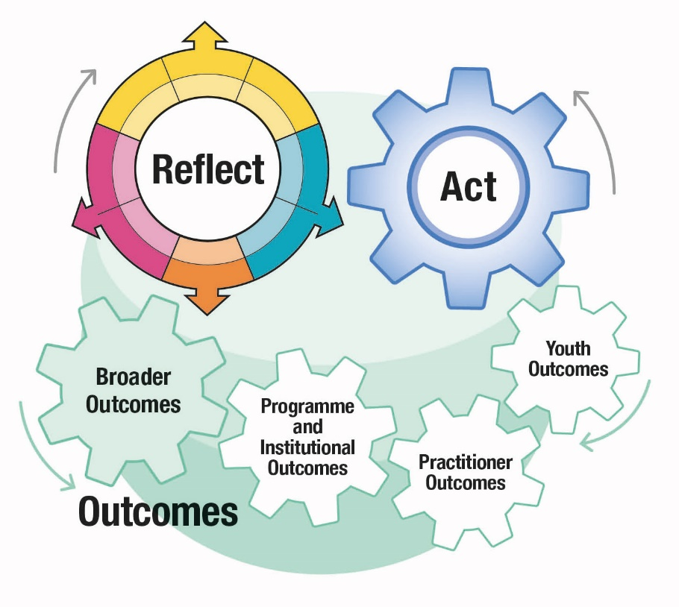
Figure 1: YESTEM Model for equity in ISL including three components: reflect, act and outcomes. Outcomes include youth outcomes, practitioner outcomes, programme and institutional outcomes and broader outcomes.
Please see yestem.org for the full model and related Insight documents detailing each component.

What are Equitable Youth Outcomes?
Many practitioners and organisations think about the kinds of outcomes young people generate through ISL participation in terms of enjoyment, fun, learning, socialising, and skill development.
While there are many frameworks available to evaluate ISL outcomes, there is little to help practitioners assess the extent to which outcomes are equitable.
Positive outcomes tend to be easier to come by for young people from dominant groups, while young people from minoritised backgrounds experience injustices that impact the extent to which they feel respected, valued and represented in ISL, how far they are supported to feel that they belong in ISL in ways that are true to themselves and affects the outcomes of their participation. Equitable practice is not just about what you do, but how and why you do it. The stance taken and the principles underlying a particular programme or activity will profoundly shape its potential for either reinforcing, or transforming social inequalities.
The focus on equitable youth outcomes helps to ‘cut through’ generic outcomes data to identify outcomes with a greater equitable potential.
While a programme might support a range of positive outcomes for young people, this focus can help you identify and critically question those that are reinforcing positive STEM outcomes and experiences for privileged young people versus those that are supporting equitable outcomes for young people from minoritised communities.
The model focuses on what makes particular outcomes equitable. We frame equitable youth outcomes as those that challenge, disrupt and transform unjust dominant power relations and practices through ISL participation, and those that meaningfully support young people from minoritised groups in gaining positive outcomes, feel welcome and have a sense of ownership and ‘rightful presence’ within an ISL setting.
Equitable youth outcomes can be individual and/or collective; they both support the individual young people and transform unjust power relations in support of new patterns of participation and engagement.

The Equitable Youth Outcomes Model for informal STEM learning
- The Equitable Youth Outcomes Model for ISL uses the Equity Compass, which we developed with YESTEM ISL practitioners to reflect on and develop equitable practice. The Equity Compass helps us consider which outcomes are more and which are less equitable, through applying four main ways to think about equity.
- The model is organised by Question starters (corresponding to the Equity Compass areas) that practitioners could use to identify equitable youth outcomes.
- The model does not provide a prescriptive, definitive method for capturing equitable youth outcomes. Rather, it provides a framework and guidance for how different dimensions of equity could be applied to consider outcomes (whatever outcomes you might be recording for your programme or activity). To illustrate how this could be done, we apply the Equity Compass to consider four types of outcomes that we focused on in the YESTEM project: STEM capital, STEM identity work, Agency+ and STEM trajectories.
- Equitable youth outcomes can be identified through qualitative and quantitative data. See the two Spotlights below with examples of what data practitioners might collect to identify equitable youth outcomes.
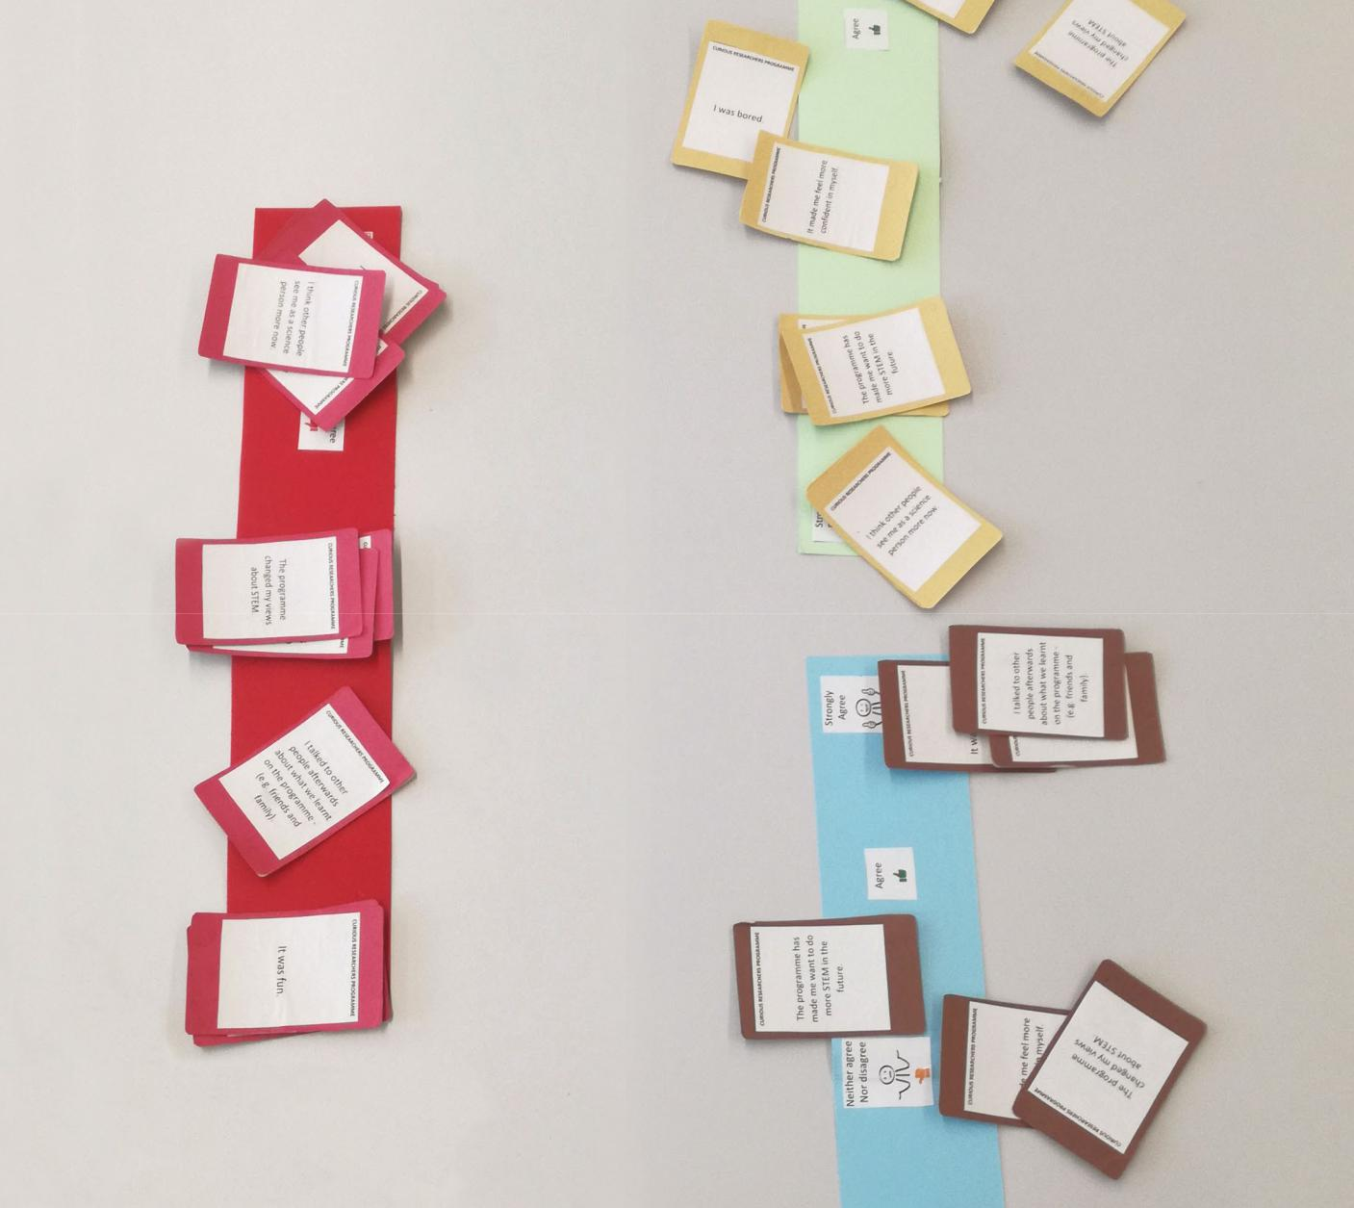
Figure 2: Example of evaluation - using cards stating different outcomes, which young people place on the scale from disagree to agree.
- Start by thinking about the Equity Compass dimensions and the practices they highlight. Then consider ‘so what’ by working with the question starters and endings from the Equitable Youth Outcomes Model for ISL to reflect on practices in your context.
- In the next step, think about ‘how do we know’ – what data you might already have (or could collect going forward) to identify equitable outcomes.
- Finally, consider ‘now what’, setting priorities for collecting and using data and further developing your practice to support equitable outcomes.
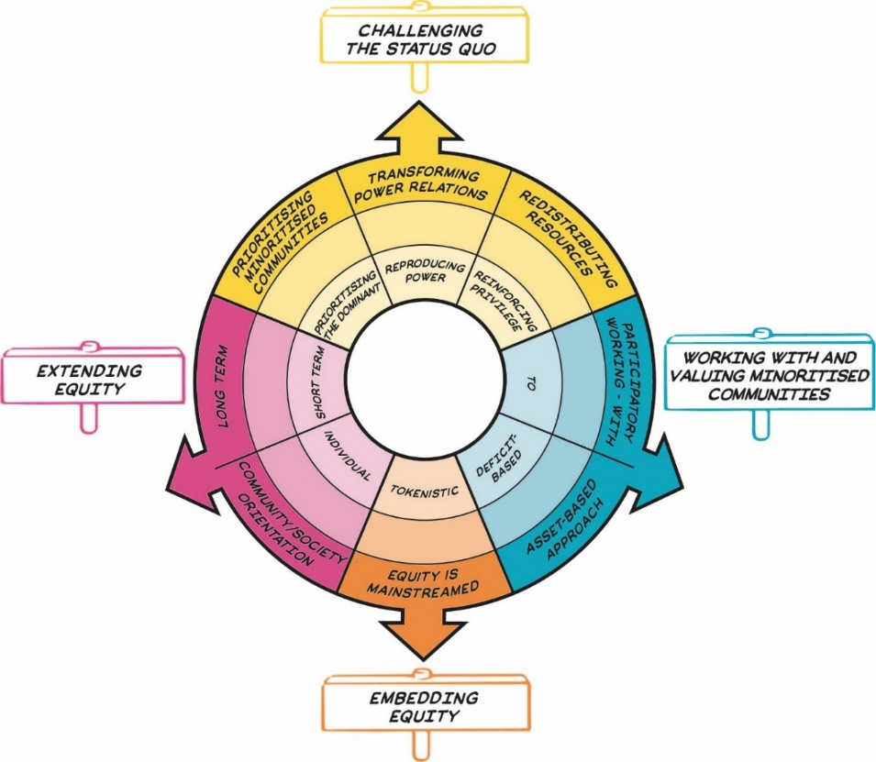
Figure 3: The Equity Compass showing eight dimensions of equity, grouped into four overarching areas represented by signs that sit outside the main circle. Details are presented in Table 1.
Table 1: The Equity Compass sections
Area | Equity dimension – outer layer of the Equity Compass (strong practice) | Inner layer of the Equity Compass (weak practice)
Challenging the status quo | Transforming power relations | Reproducing power
Challenging the status quo | Prioritising minoritised communities | Prioritising the dominant
Challenging the status quo | Redistributing resources | Reinforcing privilege
Working with and valuing minoritised communities | Participatory working - with | To
Working with and valuing minoritised communities | Asset-based approach | Deficit-based
Embedding equity | Equity is mainstreamed | Tokenistic
Extending equity | Long term | Short term
Extending equity | Community/ society orientation | Individual

Table 2: Equitable Youth Outcomes Model
The Equity Compass area | Question starter | Youth outcomes
 |  | STEM capital | STEM identity | Agency + | STEM trajectories
Challenging the status quo | To what extent was the status quo challenged, so that youth … | … experience ISL as disrupting and transforming what counts as STEM (beyond traditional content, skills and practices)? | … experience ISL as disrupting and transforming who counts in STEM (beyond traditional representations)? | … have opportunities and support to use STEM to challenge injustices and ‘make a difference’ through their contributions? | … feel supported towards socially just life trajectories?
Working with and valuing minoritised communities | To what extent have ISL practitioners worked with and valued minoritised communities, so that youth from these communities ... | … feel that their knowledge, skills and experiences are recognised, valued and expanded? | … feel that their identities/ histories/ communities are valued and represented?  …have a sense of ownership and belonging within ISL and STEM? | … feel that they have authority and are being heard? | … feel supported in their desired life trajectories, in STEM and beyond?
Extending equity | To what extent has equitable ISL practice been extended, so that … | … equitable youth outcomes are sustained over time (long-term)?  ... ISL supports not only individual but also wider equitable outcomes (e.g., for others, community, society)?
Embedding equity | To what extent has equitable ISL practice been embedded, so that… | … equitable youth outcomes are prioritised across the whole ISL organisation?

Spotlight on practice: Identifying equitable youth outcomes at a community zoo (UK)
Cole runs educational programmes with young people at a community zoo and wanted to use the model to inform how he collects data, reflects and then refines his holiday programme.
Prior to his involvement with the YESTEM project, Cole would typically record outcomes from his sessions using a short exit survey that anonymously asked about things like the enjoyment of the activities (‘How much did you enjoy the activity?’). Cole admitted that the evaluations often resulted in “hearing what we wanted to hear” because the “topic that we’re talking about is quite exciting and it is fun.” On reflection, Cole told us that the equity focus was implied but there was little data to understand if the programmes supported equitable youth outcomes, or not, or even moving in the right direction.
Considering the Equity Compass, Cole decided to rethink his approach to collecting data and making claims about outcomes for the new holiday programme for young people from low-income families. For instance, Cole planned to keep observational records during the sessions and follow up with individual participants about their outcomes and whether the programme activities lead to ‘making a difference’ and support wider outcomes. Committed to challenging the status quo, Cole also intended to lead a group discussion about what and who counts as science (which he anticipated would contribute to data about how the programme is helping to challenge dominant views about what it means to do science and be a science person).
Cole found it difficult to know the extent to which programmes were supporting minoritised young people. He planned to improve this by i) collecting key demographic data alongside other evaluation data, and ii) analysing the data by paying attention to how outcomes might differ between young people, and the extent to which the programme was supporting minoritised young people (and thus redistributing resources rather than reinforcing privilege). Cole decided to keep an exit survey, but revised the items by adding questions that would help identify equitable outcomes, such as relating to participatory practice and the asset-based approach (e.g., ‘I was able to make a contribution during the programme.’; ‘I felt heard.’).
Cole reflected on how a stronger focus on equity has helped the zoo embed an equitable stance in everything they do, ensuring that supporting equitable practice is at the heart of the zoo’s practice.
“As conservation educators we always label our stuff as for everyone: everyone’s welcome, … but, in practice, it’s not always this way. So, by achieving these equitable outcomes, meaning that we have to proactively do something from when we’re designing the programme to when we’re marketing the programme and allocating spaces, delivering the programme and then evaluating the programme, at each step of the way, it’s our actions that are going to affect how equitable the programme is and, therefore, the outcomes.”

Spotlight on practice: Identifying equitable youth outcomes from a Youth Action Council (US)
Chris has worked with a group of young people via the Youth Action Council (YAC) programme at a Science Centre. Together with his colleagues, he was keen to use YESTEM tools to examine youth outcomes from an equity perspective.
He recorded outcomes from the YAC sessions through i) collecting the artifacts that young people generated during the sessions, ii) engaging in conversations with young people, asking about their experiences and suggestions for the session activities, and iii) using exit surveys that asked about the enjoyment and challenge of the activities (‘What did you enjoy and why? What was challenging and why?’) and relevance of the activities to their lives (‘How do your projects connect to your life?’).
YAC involved several young people from minoritised backgrounds (Black, lower socioeconomic backgrounds) and Chris was keen to record how outcomes they gained compared to more privileged (White, wealthier) young people. For instance, Chris paid attention to not only what outcomes young people were gaining, but also who was gaining the outcomes, to ensure that minoritised young people are supported.
Chris used these outcomes data he collected from every YAC session to inform his planning of the next YAC sessions. For example, he designed an activity in which youth were encouraged to design and create posters that would showcase their interests and talents in science and making. This activity was designed drawing on his reflection on the outcomes data where he identified that some of the participating young people did not feel that they were able to share their interests during the session and did not always feel that their contributions were being heard.
Chris’ practice also illustrates that outcomes do not need to only be collected at set points, or at the end of the programme, but that practitioners can engage in dialogue with young people throughout their participation (through what we called moment-to-moment engagement with youth outcomes). For instance, during the aforementioned poster activity, several young people criticised Chris’ instructions (e.g., ‘It feels like schoolwork.’, ‘We don’t wanna do this!’, ‘You write all this stuff, and in the end it doesn’t really matter.’), which Chris interpreted as young people feeling that the session is done ‘to’ them rather than meaningfully created ‘with’ them (reflecting participatory approach) and that they felt that their work was not recognised (their assets not being valued). Chris acknowledged the critique as valuable evaluation insight, and acted upon it immediately to improve the session toward becoming more participatory, inviting youth to be the organisers and co-producers of the ISL activity.

The Equitable Youth Outcomes Model: Worksheet for recording equitable outcomes
Use this worksheet to map out what you know about equitable youth outcomes in your setting, what evidence you already have and what further evidence you need to answer the questions. You can use the worksheet to map equitable outcomes in a programme over time. You can use the model to plan equitable outcomes into your practices (formative evaluation), as you go through a particular programme (on-going evaluation) as well as at the end of a piece of work (summative evaluation).

Table 3: Equitable Youth Outcomes Model worksheet
The Equity Compass area | Question starter | Youth outcomes | What evidence do I already have? | What further evidence might I need?
Challenging the status quo | To what extent was the status quo challenged, so that youth … | … experience ISL as disrupting and transforming what counts as STEM (beyond traditional content, skills and practices)?  [STEM capital]
… experience ISL as disrupting and transforming who counts in STEM (beyond traditional representations)?
[STEM identity]
… have opportunities and support to use STEM to challenge injustices and ‘make a difference’ through their contributions?
[Agency +]
… feel supported towards socially just life trajectories?
[STEM trajectories]
Working with and valuing minoritised communities | To what extent have ISL practitioners worked with and valued minoritised communities, so that youth from these communities ... | … feel that their knowledge, skills and experiences are recognised, valued and expanded?  [STEM capital]
… feel that their identities/ histories/ communities are valued and represented?
…have a sense of ownership and belonging within ISL and STEM?
[STEM identity]
… feel that they have authority and are being heard?
[Agency +]
… feel supported in their desired life trajectories, in STEM and beyond?
[STEM trajectories]
Extending equity | To what extent has equitable ISL practice been extended, so that … | … equitable youth outcomes are sustained over time (long-term)?  ... ISL supports not only individual but also wider equitable outcomes (e.g., for others, community, society)?
Embedding equity | To what extent has equitable ISL practice been embedded, so that… | … equitable youth outcomes are prioritised across the whole ISL organisation?

Ideas of evidence to collect: interviews, surveys, group discussion, meeting records, social media posts, observations.

Who might use the Equitable Youth Outcomes Model and how?

Informal STEM learning practitioners and organisations

- The model is designed to be used alongside existing formative, on-going and summative evaluation tools to support a focus on equity.
- The model can also be used as a reflective tool to help support equitable practice (together with the Equity Compass) when planning programmes, exhibitions, staff development and so on, to support opportunities for enhancing equitable youth outcomes across different institutional practices.
- Use the model to help foreground the issues of equity when thinking about and planning for young people’s outcomes from ISL, particularly in working with minoritised communities.

Funders

- Funders could help by supporting meaningful and complex approaches to evaluation and project reporting that take equity seriously and recognise the complexity of evidencing equitable outcomes.
- Support long-term investment in young people, ISL practitioners and ISL institutions to help support the achievement of equitable, consequential outcomes for all parties.

About the YESTEM project
- Over four years, our project involved researchers, ISL educators and young people working in partnership to develop new understandings and insights about how ISL might better support equitable outcomes for young people aged 11-14 from minoritized communities.
- Our project partnership involved data collection in the UK and the USA with partners in two science centres, two community STEM clubs, a zoo and a digital arts centre.
- Overall, 260 young people and 30 practitioners took part.
- In the wider project we also conducted surveys with 2,783 young people (1,873 in the UK and 910 in the US).

Additional resources
- See YESTEM Insight 1: The Equity Compass: A Tool for supporting socially just practice. (informal STEM learning edition)
- See a 2-minute animation explaining the Equity Compass.

Website: yestem.org
Follow on Twitter: @YESTEM_UK

This material is based upon work supported under a collaboration between the National Science Foundation (NSF), Wellcome, and the Economic and Social Research Council (ESRC) via a grant from the NSF (NSF grant no. 1647033) and a grant from Wellcome with ESRC (Wellcome Trust grant no. 206258/Z/17/A)
Disclaimer
Any opinions, findings and conclusions or recommendations expressed in this material are those of the author(s) and do not necessarily reflect the view of NSF, Wellcome, or ESRC.

How to cite this publication: YESTEM Project Team (2021). YESTEM Insight 3.1: Equitable Youth Outcomes Model for informal STEM learning. yestem.org

We use the term ‘minoritised’ as a shorthand for individuals and communities who are minoritised by dominant culture/society. Using ‘minoritised’ rather than ‘minority’ puts the emphasis on the systemic issues and structures that are failing to sufficiently recognise, support and value some people. People can be minoritised within a particular society depending on their race/ethnicity, gender, socioeconomic background, dis/ability, sexuality and other social axes. We acknowledge that labels are always imperfect and provisional and can vary in meaning and interpretation over time and between contexts, e.g., internationally, across different professional sectors, communities and between researchers, practitioners and young people.
By ‘rightful presence’, we refer to young people being welcomed into the ISL community, where their discourses, practices, knowledge and lived experiences are powerful resources for meaningful engagement. The framing of rightful presence underscores how young people have long been engaged with science, whether this is recognised by those in power or not. See Calabrese Barton & Tan (2020). Beyond equity as inclusion: A framework of “rightful presence” for guiding justice-oriented studies in teaching and learning.

