YESTEM Insight #1 (Accessible version)
Original version: https://yestem.org/wp-content/uploads/2022/03/Equity-Compass-for-ISL.pdf

The Equity Compass: A tool for supporting socially just practice

What is the Issue?
- Diversifying participation in science, technology, engineering and mathematics (STEM) remains a key challenge for policy and practice internationally.
- While informal STEM learning (ISL) settings have considerable potential to engage diverse communities, on the whole the sector does not have a diverse participation profile.
- The sector would benefit from improved capacity to understand and engage with the complexity of issues pertaining to equity and social justice, in both policy and practice.
- Equity refers to a model of social justice that attempts to challenge and transform social inequalities and work towards more just power relations. Whereas equality often means treating everyone the same and/or providing the same opportunities to all, an equity approach advocates differential treatment according to need, while also recognising and valuing differences between people.
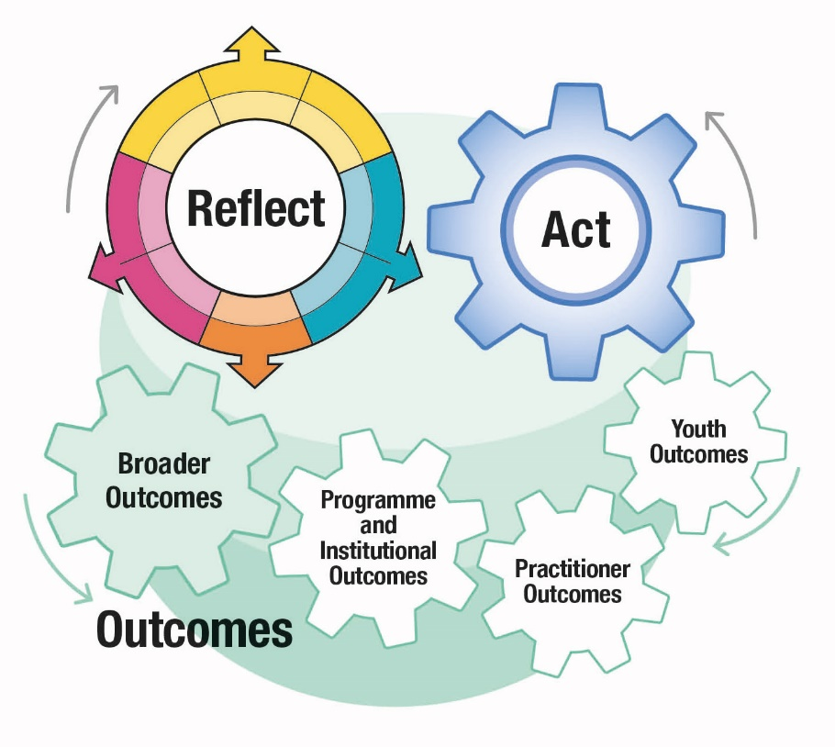
Figure 1: YESTEM Model for equity in ISL including three components: reflect, act and outcomes. Outcomes include youth outcomes, practitioner outcomes, programme and institutional outcomes and broader outcomes.
The Equity Compass is the basis of the Reflect component of this model. Please see yestem.org for the full model and related Insight documents detailing each component.

The Equity Compass: A tool for supporting socially just practice
The initial version of the Equity Compass included eight separate dimensions (axes) of equity; the version presented here was developed further through feedback from informal STEM learning practitioners and teachers, resulting in grouping the eight axes into four overarching areas.
- Equitable practice is not just about what you do, but how and why you do it. The stance taken and the principles underlying a particular programme or activity will profoundly shape its potential for either reinforcing, or transforming social inequalities.
- The Equity Compass tool helps users to adopt a social justice mindset when developing and reflecting on their policy and/or practice. It prompts them to consider multiple dimensions of equity, as represented by the eight segments of the Equity Compass.
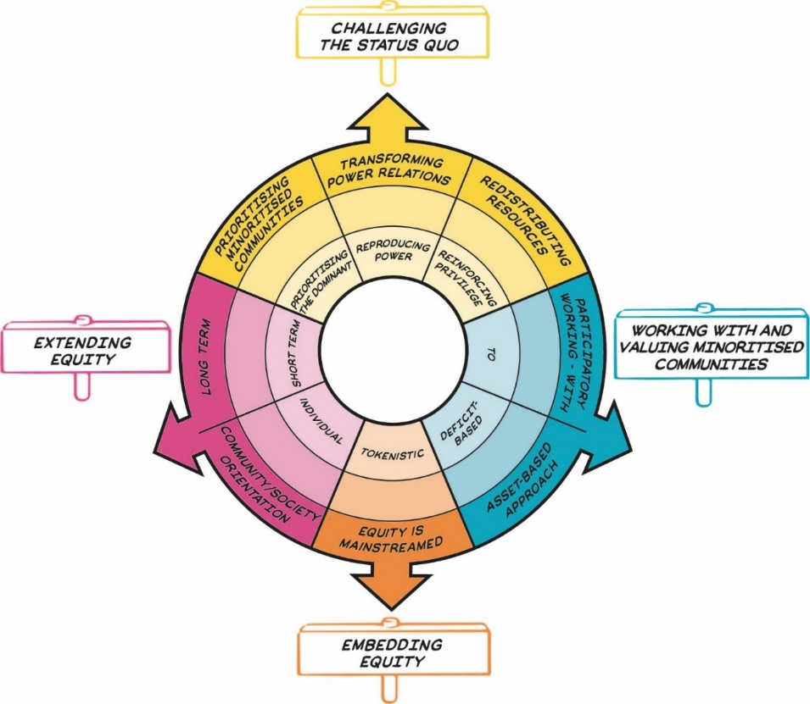
Figure 2: The Equity Compass showing eight dimensions of equity, grouped into four overarching areas represented by signs that sit outside the main circle. Details are presented in Table 1.

Things to consider
- The Equity Compass helps to identify how and why particular examples of practice may be more or less equitable. By mapping your practice, the Equity Compass can help support planning for improvements in equitable practice.
- By attending to each of the segments, the Equity Compass helps practitioners to identify ways to support young people’s critical STEM agency. STEM agency is the capacity for young people, particularly those from minoritised communities, to use STEM to take action in their lives on issues that are meaningful to them and which help challenge societal injustices.
- While the Equity Compass has been developed and tested within ISL settings working with young people, it has also been applied by practitioners working with adults, by teachers and educators working in formal education and in contexts beyond STEM.

The Equity Compass: A tool for supporting socially just practice
Table 1: Equity Compass sections and guiding questions
Area | Equity dimension – outer layer of the Equity Compass (strong practice) | Inner layer of the Equity Compass (weak practice) | Guiding questions
Challenging the status quo | Transforming power relations | Reproducing power | To what extent are dominant relations (e.g., ideas of scientists as white men; hierarchical relations between educators and students, narrow/elitist representations and forms of science knowledge and practice; differential experiences of ownership and belonging within STEM spaces) being reinforced vs. challenged and changed? Who has agency, power and legitimacy? Are dominant, unjust relations and conditions being reproduced, challenged or meaningfully transformed?
Challenging the status quo | Prioritising minoritised communities | Prioritising the dominant | Whose interests, needs and values drive the policy and/or practice? Those of the dominant (e.g., the institution, STEM pipeline, industry, economy) or minoritised young people and communities?
Challenging the status quo | Redistributing resources | Reinforcing privilege | Are resources and efforts mostly directed at more privileged people and those who already feel ‘science-y’? How are the STEM knowledge, skills, social networks, and chances of minoritised people being supported?  Is the approach/experience reinforcing dominant relations and conditions, taking a compensatory approach or is it more meaningfully redistributing resources and changing ideas about what resources are valued?
Working with and valuing minoritised communities | Participatory working - with | To | Is the practice being done ‘to’, ‘for’ or ‘with’ minoritised young people and communities? Who has ownership and voice in decision making?  How participatory is the practice? Are young people producers or just consumers of science? Is the practice exploitative/tokenistic? Are young people valued partners? How is youth identity and agency being supported?
Working with and valuing minoritised communities | Asset-based approach | Deficit-based | How are the interests, knowledge, identities and resources of minoritised young people and communities being recognised and valued (an ‘assets- based’ approach)? Are (some) participants treated in deficit terms (as ‘lacking’ information, aspiration, interest and somehow being ‘out of place’)? To what extent are all participants valued and recognised for who they are, rather than who they are not?
Embedding equity | Equity is mainstreamed | Tokenistic | How central, major, intentional and foregrounded are equity issues in the programme and organisation? Are equity issues everyone’s core business or are they minor, token, peripheral concerns (e.g., restricted to special programmes, and temporary funding)? How are issues and experiences of injustice recognised and challenged?
Extending equity | Long term | Short term | Is the practice one-off, short-term or longer-term? Is attention being paid to supporting young people’s trajectories and progression over time and across contexts? How are youth pathways being brokered and supported both within the experience and beyond the moment/programme/setting?
Extending equity | Community/ society orientation | Individual | To what extent does the practice contribute to individual outcomes? To what extent are the outcomes also collective (e.g., for families, wider communities) and/or the wider field? Do the outcomes extend beyond the specific experience or programme?

How to use in practice: Reflect and Act
- Each axis of the Equity Compass has a set of associated Guiding Questions to help you to reflect on your policy and/or practice. You can apply the Equity Compass either generally or specifically, using it to consider anything from an organizational top level policy down to a single session within a programme.
- Use the Guiding Questions to help you reflect critically on each Equity Compass axis – where would current practice ‘sit’ on each arrow? You can draw or map it on to the Equity Compass.
- Use the Equity Compass to identify areas that you would like to work on further. For instance, you might want to prioritise areas where your mapping sits in the centre zones of the Equity Compass. Use the questions and axes to help prompt ideas about how future programmes and activities might be planned in line with the eight dimensions of equity.
- Track your progress towards more justice- oriented practice by charting outwards movement on the Equity Compass axes.

Spotlight on practice
The Equity Compass is already proving to be a useful tool within ISL settings. Project partners have told us it has helped them rethink how they work with minoritised young people, introduce more participatory approaches, improve professional development and better articulate where they want to be going.
For instance, practitioners at a city science centre in the UK (with over 200 staff and volunteers) described how, despite their embracing of the centre’s public commitment to prioritising underrepresented communities and improving inclusion and equitable practice, they struggled to align these goals with the complexities of practice. Tessa, who worked with young people, was sometimes frustrated by “institutional box ticking” approaches and Barbra similarly felt that there is “never enough head space” to engage with equity issues within her busy role. For Scott, ‘equity’ was a new concept that he was trying to understand and put into practice.
Like many others, these busy practitioners struggled to translate complex equity and social justice issues from individual practices to a collective stance on reflective action and tracking change.
They found the Equity Compass useful in many ways. For instance, Barbra felt that it helped her to articulate changes needed to better support more equitable practice and to present these to the management team: “It’s great to be able to say, we considered this programme/ activity using the Equity Compass and look, our approach falls short, so let’s re-address”.
Tessa and Scott both found it helpful for individual reflection and planning and for having equity-based conversations with others in the organisation.
Cole, an ISL practitioner in a community zoo, felt that the approach “has truly contextualised my teaching methods and highlighted areas in which I can improve”.
He felt it gave him new motivation, inspiration and ideas and helped him “more formally, clearly and confidently assist other practitioners in my industry”. Cole added: “I’ve used the Equity Compass on existing and new programmes, and identified areas in which we can improve on our equitable practice, ensuring the sessions we run are more socially just.”

About the YESTEM project
- Over four years, our project involved researchers, ISL educators and young people working in partnership to develop new understandings and insights about how ISL might better support equitable outcomes for young people aged 11-14 from minoritized communities.
- Our project partnership involved data collection in the UK and the USA with partners in two science centres, two community STEM clubs, a zoo and a digital arts centre.
- Overall, 260 young people and 30 practitioners took part.
- In the wider project we also conducted surveys with 2,783 young people (1,873 in the UK and 910 in the US).

Additional resources
- See a 2-minute animation explaining the Equity Compass.
- For the full range of Insights documents summarising the project’s tools and resources, including Core Equitable Practices and Equitable Youth Outcomes Model, please see yestem.org

Website: yestem.org
Follow on Twitter: @YESTEM_UK

This material is based upon work supported under a collaboration between the National Science Foundation (NSF), Wellcome, and the Economic and Social Research Council (ESRC) via a grant from the NSF (NSF grant no. 1647033) and a grant from Wellcome with ESRC (Wellcome Trust grant no. 206258/Z/17/A)
Disclaimer
Any opinions, findings and conclusions or recommendations expressed in this material are those of the author(s) and do not necessarily reflect the view of NSF, Wellcome, or ESRC.
How to cite this publication: YESTEM Project Team (2021). YESTEM Insight 1: The Equity Compass: A Tool for supporting socially just practice. yestem.org

We use the term ‘minoritised’ as a shorthand for individuals and communities who are minoritised by dominant culture/society. Using ‘minoritised’ rather than ‘minority’ puts the emphasis on the systemic issues and structures that are failing to sufficiently recognise, support and value some people. People can be minoritised within a particular society depending on their race/ethnicity, gender, socioeconomic background, dis/ability, sexuality and other social axes. We acknowledge that labels are always imperfect and provisional and can vary in meaning and interpretation over time and between contexts, e.g., internationally, across different professional sectors, communities and between researchers, practitioners and young people.

